From Bloomberg The tragic crash of the Boeing 737-800 in China
The China Eastern jet crash in a mountainous patch of the country’s south is both a tragedy and mystery.
All 132 on board are presumed dead. The passengers included the chief financial officer of Dinglong Culture, a Guangdong-based entertainment company, a newlywed and a party of six traveling to a funeral.
Nothing seemed strange before the Boeing 737-800 fell out of the sky at nearly the speed of sound just 100 miles from its destination. The weather was fine. Flight MU5735 was cruising at about 29,000 feet (8,839 meters). The plane halted its descent for some 10 seconds, and even climbed briefly, before its final downward spiral, Flightradar24 said. A video taken by a nearby mining company showed the plane intact until its final moments.
An equipment malfunction. Pilot illness or suicide. Even a terror attack. Nothing is being ruled out. The 737-800 is considered one of the safest aircraft, with 11 fatal accidents from some 7,000 planes since 1997, said aviation consultancy Cirium. The three pilots included one of China’s most experienced commercial aviators, and all had good performance records and stable family backgrounds. Investigations can take years.
A lot is riding on the truth. China’s strong aviation safety record came from overhauling the industry after a spate of deadly accidents in the 1990s. Domestic insurers could be on the hook for up to 510 million yuan ($80 million) on this crash, according to Bloomberg Intelligence.
President Xi Jinping tasked his right-hand man, Vice Premier Liu He, to oversee the investigation, and China has invited the U.S. National Transportation Safety Board to join “on the ground.” While it’s customary for the manufacturing nation to be onsite, given tense U.S.-China relations it wasn’t guaranteed.
“If they’re going to be a world player in aviation, they’ve got to show the same timeliness, same thoroughness, same specificity” as U.S. and European investigators, BI analyst George Ferguson said.
Of the two black boxes only the one with cockpit voice recordings has been recovered — and it is “severely damaged.” The second black box, if found, will contain more information on flight parameters, from speed and altitude to flap positioning and heading.
In the meantime, China Eastern has grounded its 737-800s and canceled thousands of domestic flights, hampering an industry already reeling from Covid restrictions. Cancellation rates for domestic flights in China remain high at 76% as of Thursday.
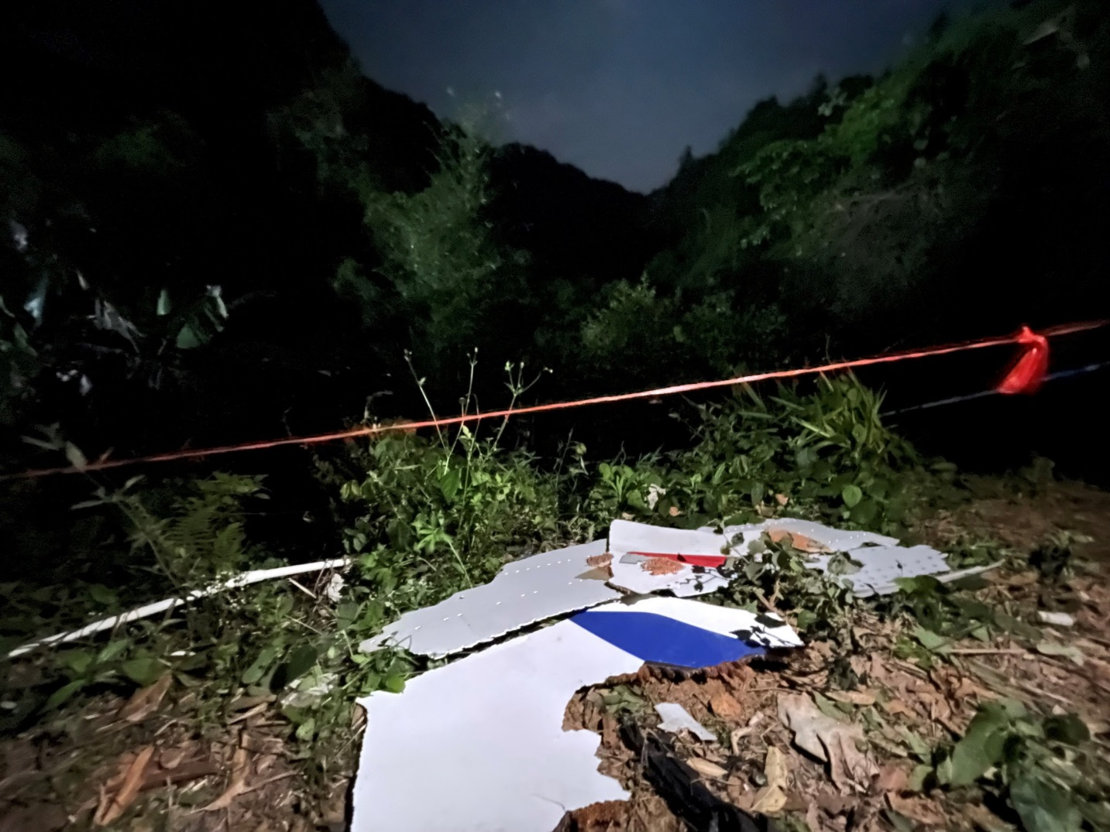
Pieces of China Eastern's wreckage in China's Guangxi Zhuang Autonomous Region, on March 22. Photographer: Xinhua News Agency/Xinhua News Agency
Whether other airlines follow remains to be seen. China has nearly 1,200 of the jets, the world’s largest fleet, said aviation consultancy IBA Group.
The tragedy is terrible timing for Boeing. It was on the brink of returning its 737 Max jets, grounded after fatal crashes in 2018 and 2019, back to service in China. The U.S. aircraft manufacturer has about $4.5 billion of built jets destined for China in its storage lots, according to BI’s Ferguson.
“Consumers may not want to fly on a 737 until the cause of the China Eastern crash is determined not to be a design or manufacturing issue,” Cowen analyst Cai von Rumohr said in a note. “Hence, isolating the cause of the crash will be critical.”

