The December 10, 2021 extraordinary tornado stormed through a half dozen states and smashed thousands of homes and ruined the lives of countless Americans.
Why should we donate to the support the victims, and many must be veterans, of the recent huge tornado disaster?
The December 10, 2021, level EF-4 gargantuan tornados (with speeds of up to 165 mph) that smashed through 6 states (Kentucky, Arkansas, Illinois, Missouri, Mississippi, Alabama, ) destroyed around 15,000 buildings (structures) and will take many years to replace, or repair, these buildings, most of which were the homes of our citizens. We assume that among the thousands affected, hundreds are likely veterans.
Repair work will take a huge workforce (that doesn’t exist today), and require enormous amounts of building materials. The demand for supplies alone will drive prices up. The cost of lumber has doubled in the last few months- even before fire and tornadoes destroyed our forests. With their homes (and much of its contents) splintered, it will take years before replacement homes are restored. What will they do in the meantime?
Thousands are living in tents, as motels and hotels were destroyed in the local area. Living in tents for a few days is tolerable, but when tents are the long term residence for people, there is, and will be, enormous amount of suffering, Consider how tragic it would be for anyone to live in tent indefinitely and not have access to running water or a real bathroom or shower facilities indefinitely.
Also these victims now depend on charity for food, and community kitchens a long time. Some people may never live in a real house again for years. Public bathrooms and showers are now a routine.
Living in tents gets old very quickly when that is all you have to live in day in and day out. It’s stressful really fast. People living is these less than optimal situations will likely have health problems and recovery living in tents is not optimal for recovery from any medical condition.
People who must live in these fragile situations for extended period of time will likely have serious mental problems. If these already fragile locations are hit with more bad weather and more tornadoes, the harm to many thousands of affected citizens will be severe and the burden to care for so many people will be an enormous burden on our entire country.
They need help and help now. So even though our Post has just donated $2,000, the need for more funds is critical as there are no quick solutions. It has been estimated that it may take decades to restore the housing and buildings lost to tornadoes.
Please give til it hurts, because all the people in a half dozen states are hurting really badly.
To get our donations started strong, one member of our Post has pledged to match the first $5,000 generously contributed by other Post members. Your checks should be made out to Cathay Post 384 and note on the bottom of check that it is for Tornado relief.
Thank you for caring for our veterans (and everyone else) affected by this horrible weather.
=======================================================
Related news.

The long road back. The tornado damage in Kentucky could take decades to repair

Cities must act fast to take advantage of support while they can
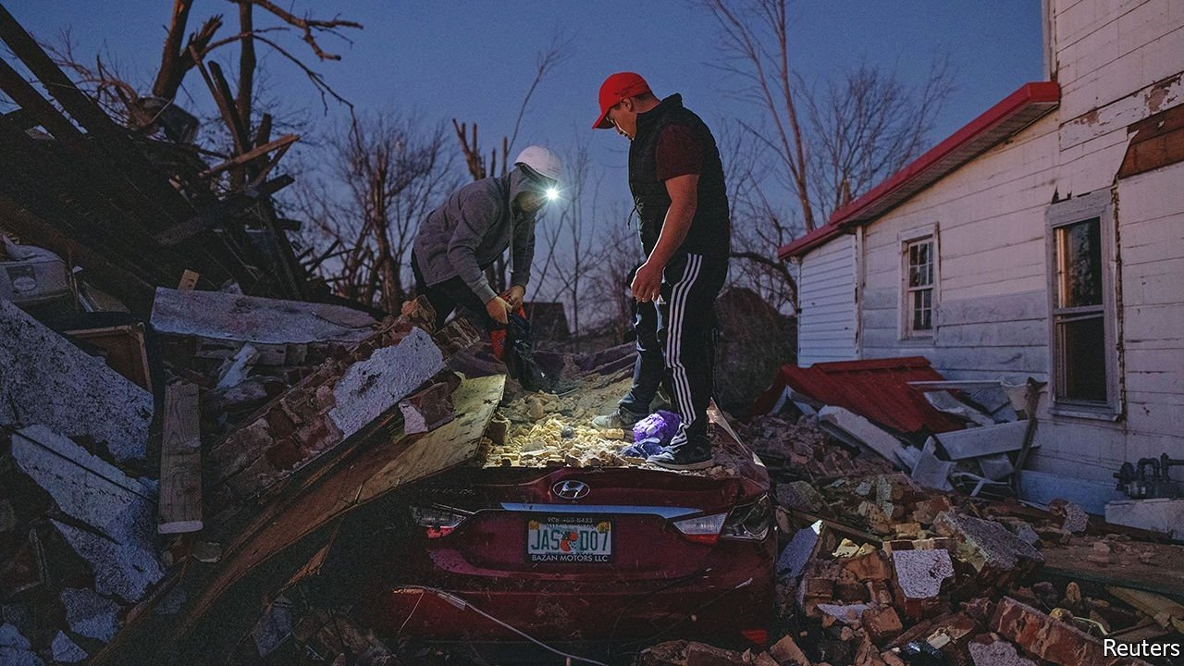

The Economist, Dec 18th 2021. Mayfield, Kentucky
AT THE FIRST Baptist Ministries Centre in downtown Mayfield, Kentucky, a huge cross used to be visible through a large window overlooking the crossroads. Now it stands, perilously, in the open air. The entire rest of the front of the building, as well as much of the roof, was torn off by a tornado on the night of December 10th, which flattened a large part of the rest of the town. On December 14th, the congregation were serving coffee and breakfast buns to passers-by out of the shell. “It has been an experience,” said Debbie Fowler, a 68-year-old parishioner whose son is the pastor. “We were so sick at heart to see it, it’s devastating.” But, she says, the town will come back. “It won’t look the same, but the people will be the same. This is a close-knit community,” she says.
The tornado that hit Mayfield was the worst to have hit America since one destroyed much of Joplin, Missouri, in 2011. As well as tearing up Mayfield, it wrecked buildings in five other states across the Midwest and South. By December 15th, 88 people were known to have been killed, 74 of whom were in Kentucky. Dozens more were still missing, while hundreds have been made homeless. Andy Beshear, Kentucky’s governor, described it as the “worst, most devastating, most deadly tornado event” in his state’s history. On December 15th Joe Biden visited Mayfield to survey the damage himself, and announced federal aid to cover the costs of rebuilding. And yet recovery from natural disasters is rarely easy. The population of New Orleans is still 20% lower today than it was before Hurricane Katrina in 2005. Many smaller towns like Mayfield have struggled to retain population even without tornadoes. Will it really bounce back?

