Los Angeles County Chinese Americans and anyone, who looks Asian, are fearful of attacks by other Americans.

The many examples of attacks on Asians, some fatal, has resulted in fear going out to shop, dine, or just taking a walk.

Los Angeles county is not unique. Check out New York City, San Francisco, Oakland and pollsters will find frightening fear among Chinese Americans (and anyone who looks Asian) in all locations where there are Chinese Americans. Where there are Chinatowns and Chinese American shop, dine out, or just taking an outside walk, there is much fear of being attacked, either to be robbed, or beaten, or push into the path of a subway train.

What can we do about? In some locations, there are young volunteers, who are sometimes non-Asians, who escort senior Chinese Americans, and other Asians when they go shopping in local Chinatowns. While that is good news, escorts are not available for everyone, and even if we could always have a number Bruce Lees guarding all Asians, the problem does not go away. Why has this happened in the recent history (past 2 years).

The main reason for those people who must threaten and hurt Chinese American, and anyone who look Asian, is that of hatred for China. As some historians have noted, Chinese Americans are the forever foreigners, and it is much easier for those paranoid, to hurt and harm foreigners than other American citizens.

Few Americans know anything about China, few have visited China, so those who hate Chinese Americans because of our race, learn all they know about today’s China from the media, especially when the media reports on the comments of national leaders, including military leaders, who fear the growing military and economic strength of China. And many have practically declared her our enemy. We now have a mutually deteriorating situation as for the first time in history, the Chinese are calling us their enemy. Since the Chinese first met Americans in the 18th Century, most Chinese have loved and admired America. The Chinese call America, Mei Guo, the most beautiful country – the country of opportunity. In the Chinese language, no other foreign country has such an honorable name.

As a China specialist since 1972, I agree that China has gone from a weak sister to a very strong competitor. The reality that China is no longer weak, like she has been for several thousand years, does not automatically mean that now that she is strong, that she will attempt to conquer world, or attempt to convert other nations to be like her.

Fact is, China scholars/watchers like Graham Allison, and Professor John Mearsheimer, will tell you that China believes that she is unique and her current political system, best described as Capitalist Authoritarian, works pretty well in China, but is not suited for the rest of the world.

People who still insist on calling China a Communist country don’t know what a Communist country really should be. “Communist” China has the most billionaires in the world (650 by last count, and thousands of millionaires). Marx and Engels would roll over in their graves to see Capitalism mistaken for Communist.

Chinese capitalism is very different than ours, as she is a one-party system ruled by the Chinese Communist Party (CCP), The CCP really should be renamed. Today, there is no one who calls himself or herself a Communist. Communism only lasted during the rule of Mao ZeDong from 1949-1976. Once Mao passed, his successors pursued a path of capitalism since 1978 and since then has resulted in the best economic time ever in long Chinese history.

==============================================

Source:

Majority of Asians in LA County fearful of being victims of racial attack, Kendal, AsAm News, March 22, 2022
Two-thirds of Asian Americans surveyed say they are concerned about being victims of a racial attack, reports the Los Angeles Times.
The poll conducted by the Pat Brown Institute for Public Affairs at Cal State Los Angeles found concern cut across the various Asian American ethnicities.
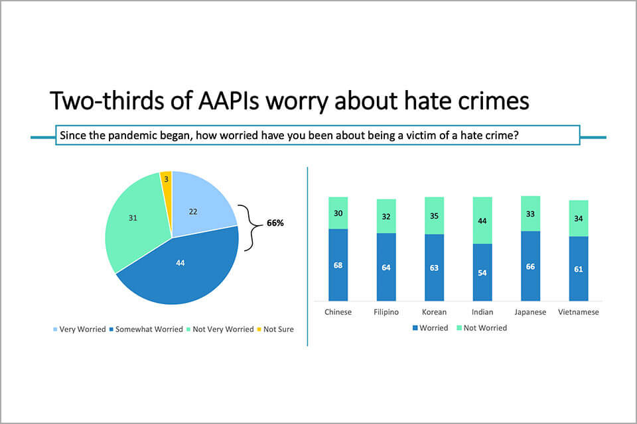 Pat Brown Institute for Public Affairs at Cal State LA graphic

The Asian Journal reported that almost one out of four of the 1500 people polled say they were a victim of a verbal or physical assault.
“It is rare to have a survey with such a large sample of AAPI residents in a single geographic area, allowing an unprecedented deep dive into the challenges, hopes, and aspirations of the fastest-growing demographic group in America,” said Raphael J. Sonenshein, executive director for PBI. “The intensity of the community’s concerns about anti-Asian speech and action, and about discrimination, is particularly timely on the first anniversary of the horrific murders in Atlanta.”
The Times reported younger generations between the ages of 18-34 reported they were a victim of hate at a higher rate than those over the age of 60- 31% compared to 11%.
The majority of the 1500 surveyed also said they support bond measures to increase support for supportive services and housing.
Most said they supported funding for police services to remain the same or increase with 42% saying it should not change. About half of Indian Americans and Chinese Americans supported the status quo and nearly 40% of Vietnamese Americans and Korean Americans support a slight increase.
About 60 percent support the administrations of President Joe Biden, California Governor Gavin Newsom, and Mayor Eric Garcetti.
“We find convincing evidence that in the wake of racial discrimination, Asian Americans have not withdrawn from politics. Instead, AAPIs have become more active,” said Nathan Chan, a research associate at the Pat Brown Institute.
“For a community that often feels invisible in the political landscape, the data that we are seeing today really show a community worthy of engagement,” Lian Cheun, executive director for Khmer Girls in Action said. “… The problem here is that there is simply not enough investment put into talking and outreaching to our communities.”
============================================================

