Headline: 60 Earthquakes strike off Oregon coast, with largest reaching magnitude 5.8 December 8, 2021

Post 384 colleagues and comrades, this series of earthquakes are too far away to be a near term, related threat to the Bay Area, BUT, we must all realize that the Bay Area is always a danger zone for earthquakes, so take this news as a reminder that we must always be ready.

Have at least two weeks of water and food ready so that there is time to take other needed actions. Always have at least a half tank of gas in your vehicle. Flash light and batteries, warm clothes and blanket, you should have your checklist and review it to be sure.

Amy Graff, SFGATE. Dec. 8, 2021Updated: Dec. 8, 2021 1:48 p.m.
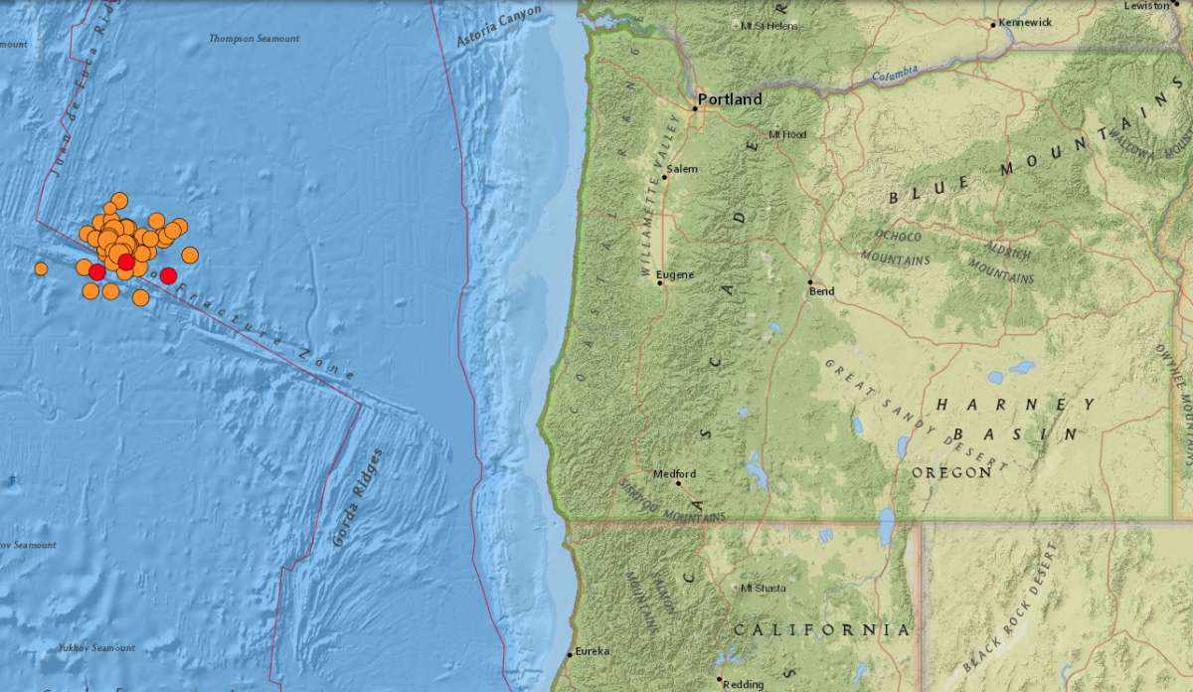
More than 50 earthquakes were recorded across 24 hours Dec. 7 to 8, 2021.
USGS
Sixty earthquakes — ranging from magnitude 3.4 to 5.8 — were recorded off the Oregon across Tuesday and Wednesday, the US Geological Survey said.
The series of quakes is centered about 200 to 270 miles west of the coastal town of Newport, far enough off the coast to not cause even light shaking on land. A dozen tremors reached a magnitude 5.0 to 5.8. Two magnitude 5.8 tremors struck on Tuesday, one at 4:36 p.m. and the other at 5:21 p.m.
All the earthquakes were recorded about 6 miles below the surface. No injuries or damage were reported by the US Geological Survey, and no tsunamis are expected, the National Weather Service said.
The earthquake activity is occurring on the Blanco Transform Fault. The fault is more active than California's famous San Andreas fault, Oregon State University said.
"Things are getting exciting out there on the Blanco Transform Fault today," Harold Tobin, director of the Pacific Northwest Seismic Network and a professor in the Department of Earth and Space Sciences at the University of Washington, wrote on Twitter. "Not felt on land — they're too far away. This is perhaps the most seismically active fault anywhere near North America, and this is not cause for alarm."
The Blanco Transform Fault lies about 200 miles west of the Cascadia Subduction Zone, where the largest quakes have occurred in the Pacific Northwest across history. A magnitude 9.0 earthquake struck on this fault on Jan. 26, 1700.
"This earthquake caused the coastline to drop several feet and a tsunami to form and crash into the land," Oregon State said.
Tobin said in an email to SFGATE that series of quakes on the Blanco Transform Fault are unusual but there's no cause for alarm that it will trigger a "Big One" on the Cascadia Subduction Zone.
The quakes on the Blanco Fault, he said, "are still quite far from it and on a different fault system, and different plate edge in fact. The Blanco Transform Fault has earthquakes very often. It’s a very active system, but not likely to present a hazard to people. That said, the last 24 hours have been unusual from the Blanco, but not in a way that increases risk in my view. As ever, there is hazard from earthquakes that folks should be aware of."

