Seniors remember the Air Force Strategic Air Command (SAC), sorry SAC is gone.
It's now the Global Strike Command (AFGSC), and what is still around is the B-52.
With upgrades the ancient B-52 is being upgraded to be active and effective, long after the B-1 and B-2 bombers are retired.
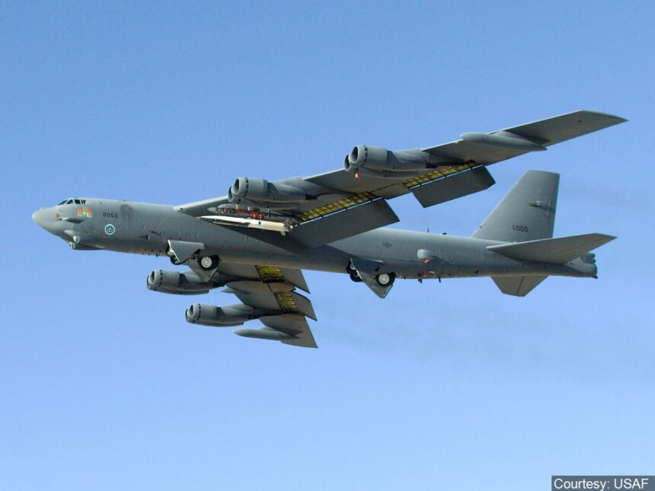
Believe it or not, the B-52 will be around after many of our seniors are gone. Born in 1952, the strategic bomber will be 70 years old in 2022. And the latest, upgraded B-52H is not going to the bone yard at Davis Monthan AFB, Az any time soon.
With ongoing enhancements on her engines, sensors and bomb carrying improvements, the B-52H will be protecting America until 2050 and beyond.
What's new about our newest B-52H?
This latest B-52 will also be able to launch the Air Force’s most advanced missiles, the new AGM-181 Long-Range Standoff (LRSO) nuclear cruise missile and the hypersonic AGM-183 Air-launched Rapid Response Weapon (ARRW). With the LRSO, the B-52 will be able to launch a nuclear missile far from one target, attack another target, or return to home base.
With new electronics and sensors, the 5 person air crew will be reduced to 4 persons.
The Weapons Bay Mod will enable “smart” weapons—such as the AGM-158 JASSM and GBU-31 JDAM—to be carried inside the bomber on weapons racks and rotary launchers, as well as on wing pylons, where they’re carried now.
Armed with latest offensive attack missiles and able to attack from far away, the B-52 is still a vital part of our nuclear deterrence.
============================================================
SOURCE:

BUFF Up

Another decade of enhancements will give the B-52 three more decades of power.
By John A. Tirpak, Air Force Magazine, Oct. 1, 2020
The nearly 60-year-old B-52 will be the workhorse of the Air Force’s bomber fleet another 30 years at least, reinvigorated with upgrades to boost its range, power, sensors, and bomb-carrying capacity. Once complete, Air Force Global Strike Command’s improvements to its 76 B-52s will provide the equivalent of an extra 22 bombers’ worth of weapon-carrying capacity.
The multitude of upgrades are already well underway and will continue into the late 2020s, providing aircraft built in the 1950s and ’60s—the last B-52 was built in 1963—with modern engines and radars, new capability to carry more smart weapons internally, new communications and connectivity, and the ability to deliver the most advanced missiles in USAF’s inventory. B-52s will also remain a key part of the American nuclear deterrent.
The changes are significant enough that the upgraded bombers could be redesignated from B-52H to “B-52H+” or “B-52J.” A new radar will mean a new nose, perhaps without the electro-optical blisters on the radome made obsolete by wing-mounted Sniper or Litening targeting pods. The aircraft’s twin-engined pods on the swept-wing bomber will also look different, and the five-person crew will likely be reduced to four.
It is going to…be a very different B-52 than what I flew as a lieutenant.
The Air Force has already spent some $1.4 billion in this round of B-52 upgrades and will invest another $3.8 billion over the next five years—and considerably more in the years that follow. Specifics are not yet available.
“It is going to … be a very different B-52 than what I flew as a lieutenant,” said Maj. Gen. Andrew J. Gebara, director of strategic plans, programs, and requirements for Air Force Global Strike Command in a September Air Force Magazine interview. In addition to its upgrades, the B-52 will also be able to launch the Air Force’s most advanced missiles, the new AGM-181 Long-Range Standoff (LRSO) nuclear cruise missile and the hypersonic AGM-183 Air-launched Rapid Response Weapon (ARRW).
Over-engineered from its inception, the B-52 airframes remain remarkably viable, with decades of structural service life remaining, Gebara said. Even with combat systems largely unchanged since the 1991 Gulf War, mission capable rates remain about 80 percent and the platform itself remains among the most versatile in the force, capable of firing standoff missiles, dropping gravity and precision-guided bombs, and laying mines.
In fact, the B-52 will long outlast the newer B-1 and B-2 bombers, both of which are expected to retire in the early 2030s when the new B-21 stealth bomber joins the force.
AFGSC Commander Gen. Timothy M. Ray wants only “must-have” upgrades, Gebara 2050 after the Air Force withdrew its B-52s from close air support and refocused them exclusively on dynamic force employment missions. The LAIRCM was primarily a defense against low-level infrared threats, Gebara said, and therefore not deemed a priority.

New Engines
Engines, however, are a must. Without new power plants, Gebara said, “it’s not going to be an airplane anymore—it’ll just be a static display.”
The B-52 Commercial Engine Replacement Program seeks to replace each B-52’s eight antique TF-33 power plants with modern, business-class jet engines. The goal: 30 percent more range or loitering time, reducing demand for aerial tanking, and increased reliability such that, once installed, the engines should never have to be removed for the remaining life of the airplanes.
Global Strike Command estimated in 2018 that the re-engining could cost $22 billion, but would save $10 billion in fuel, reduced maintenance, and personnel. The actual costs won’t be known until the Air Force selects an engine. All of the major engine suppliers are competing, and a selection is expected next spring. Rolls-Royce, GE Aviation, and Raytheon Technologies’ Pratt & Whitney are each offering variants of existing business-jet engines. Boeing, which built the B-52, will be the Air Force’s integrator.
The project will be among the first competitions relying on digital models rather than real-world flight-tests to evaluate and select a winner. The Air Force shaved about three years off what might have been a 10-year acquisition process, thanks to streamlined Section 804 authorities. Gebara expects installations could begin in about five years.
Maj. Gen. Mark E. Weatherington, commander of AFGSC’s 8th Air Force, said that once the upgrades begin, the command could see “30 to 40 refurbs,” or engine replacements, per year.

Connectivity
While the engine replacement will take time, other changes are already well underway. Nearly complete is the CONECT upgrade, which adds Combat Network Communications Technology including data links, processing power, moving map and full-color displays, and the ability to retarget weapons in flight.
As of August, Gebara said, 69 of 76 B-52s had completed the CONECT upgrade, which began in 2014. CONECT replaces a series of Band-Aid solutions to improve targeting and connectivity that cluttered cockpits with laptop computers, connecting wires, and Post-it notes.
The Rube Goldberg solutions “show the innovation of our Airmen,” Gebara said, “but it’s also nice” to see the BUFF “come up to 21st century” standards.

New Radar
The B-52’s ancient AN/APQ-166 radar is slated for replacement, its analog/mechanical systems is prone to all the shortcomings of older technology, said Gebara. He said the system was old when he first joined the Air Force nearly three decades ago.
“When I started flying the B-52, it was a 20-plus-year-old radar back then,” he said. “It’s a maintenance nightmare for those poor guys on the line.”
The replacement radar still has no official designator. Selected in July 2019, it is based on Raytheon’s APG-79/APG-82 family of systems used in the Navy’s F/A-18 Hornet, with elements drawn from the F-15E Strike Eagle. “We wanted an off-the shelf” solution that would be “most useful to us for the least amount of cost,” Gebara said. Boeing, as the integrator, chose the radar.
The active electronically scanned array (AESA) radar will go into low-rate initial production in 2024 and include improved mapping and targeting range and increased capacity to engage multiple targets simultaneously. The solid-state radar will have no moving parts—easing maintenance.
“We’ll be operations-capable” with the new radar in 2026, Gebara said.
The radar is what could enable AFGSC to reduce B-52 crews from five to four Airmen. While no firm decisions have been made, Gebara said, “If we are going to put all these upgrades in the airplane, it does make sense that [crew size] would eventually come down.” He added, however, that nothing is “imminent.”
One concept floated in the early 2000s to justify re-engining the B-52 was to enable the aircraft to become theater-wide, standoff jamming platforms. New engines would generate the needed electrical power for jamming emitters to blanket a wide area. That remains an option, but Gebara said there are no near-term plans to turn the bombers into jammers.
“It’s not an imminent program,” he said. “The plane will be around to 2050, and one thing that’s exciting about the B-52 is, you never know what’s going to come next.” But, he said, “that’s not something you’ll see in the next few years.”

More Capacity
The key attribute of the B-52 has always been its ability to carry a large payload. Now, even that is being expanded. The 1760 Weapons Bay Mod will enable “smart” weapons—such as the AGM-158 JASSM and GBU-31 JDAM—to be carried inside the bomber on weapons racks and rotary launchers, as well as on wing pylons, where they’re carried now.
“This increases the smart-weapon capacity by about two-thirds,” Gebara said. “And, if you do the math, that’s like an additional 22 bombers.”
Without the mod, only “dumb” bombs without sensors or satellite guidance could be carried internally.
In addition to added smart-bomb capacity, the B-52s will be the only aircraft to carry the AGM-181 Long-Range Stand-off missile, or LRSO, and the AGM-183A ARRW (Air-launched Rapid-Response Weapon) hypersonic missile.
The LRSO is the successor to the AGM-86 Air-launched Cruise Missile, which is now more than two decades past its original planned retirement date. The new LRSO, which is expected to be operational in the late 2020s, will be a very long-range, stealthy weapon that can be launched far from enemy air defenses. The highly classified program—USAF will not say anything about its dimensions, performance, or loadout on the B-52—will be built by Raytheon, which was selected to build the LRSO two years ahead of schedule, in early 2019, thanks to a successful Technology Maturation and Risk Reduction (TMRR) program with competitor Lockheed Martin.
The hypersonic ARRW will likely be the first operational hypersonic weapon in the U.S. inventory. Gebara said the B-52 would be able to carry two ARRWs on each of its two wing pylons. Little has been revealed about the ARRW, which uses a booster rocket to accelerate to hypersonic speed, then glides to impact.
“This thing is going to be able to go, in 10-12 minutes, almost 1,000 miles,” Gebara said. “It’s amazing.”
Gebara said the CONECT mod made it possible to add ARRW to the B-52.
With CONECT, “we get all the advanced target handoffs,” he said, “as opposed to the bombardier in the bottom of the plane typing in [coordinates] and hoping he gets it right.”
The Air Force is also pursuing a scramjet-powered, air-breathing hypersonic missile—called “Mayhem”—which would likely be smaller than the ARRW and could be carried on fighter-sized aircraft, as well as big bombers. It will build on the Hypersonic Air-breathing Weapon Concept, or HAWC, that the Air Force is developing with the Defense Advanced Research Projects Agency.
“I believe that the near-term solution that we can succeed with and field quickly is ARRW,” Ray said at a press briefing during the Air Force Association’s virtual Air, Space & Cyber Conference. “And we can do that [with] the B-52 and the B-1. We need to do that soon. And I believe, broadly, the Air Force has got it right that we want to [pursue] a scramjet missile configuration that can be launched from other platforms, as well. … We should do both.”
ARRW could achieve initial operational capability within “the next couple of years,” Ray said.
Not yet clear is how to upgrade the defensive management system for the B-52. Gebara said that capability may not be characterized for some time. A B-52H Weapon Systems Officer checks a display during a deployment to Europe in 2019. Upgrades now in the works may make it possible to eliminate one of the B-52’s five-person crew from the bomber’s “downstairs” stations. Airman 1st Class Duncan Bevan

Testing, Testing
In order to get so many new systems tested in a timely manner, Gebara said the B-52 test force will expand from two to eight aircraft: two each to test the radar, engines, new missiles, and other improvements, such as the weapons bay. That way, Gebara said, if there’s “a delay on the engine for a month or two, because they find some unknown issue, that doesn’t slow down the radar and the rest.”
Ray said he is confident AFGSC’s plans for testing and depot-level upgrade work will be effective. “I’m not concerned about the ability to do that,” he said. “I think …we’ve got a good game plan.”
AFGSC restored two old B-52s from the Davis-Monthan Air Force Base boneyard in Arizona, but Gebara said he does not anticipate any more resurrections and that other test aircraft will be diverted from operations to complete tests.
No major changes are needed to equip B-52s to launch either the ARRW or the LRSO, and because the Air Force is determined to create an open-mission systems architecture for all its aircraft, it should be able to keep refreshing the B-52 throughout its remaining lifetime.
“That’s what’s wonderful about the B-52,” he said. “It’s like an iPhone: There’s always an app that you can add to it and make changes. That’s pretty exciting.”

