Our US Army is already automated with much more automation coming.
DARPA isn’t just supporting the Air Force they are supporting our Army too. It will not be long until automated machines replace the foot soldier. There are still obstacles to overcome, but with Artificial Intelligence, in a few decades, maybe sooner, we will be deploying soldier robots, first to augment our human fighters, but eventually, it will be our robot vs their robot. We will not need as many human combat troops and that will reduce the cost of medical care for the wounded and reduce the size of medical support units. Robots also don’t get PTSD. They also don’t need medical insurance, or housing, or eat MREs and potable water in combat, and don’t get paychecks or retirement pay. They don’t need barbers, commissaries or BXs. Requests for R&R will be denied. A lot of money will be saved with Robby the military robot, if properly maintained, can fight 7/24. Future wars will be resolved in short order. No more ten year wars.
Cyber warfare will be advanced and everyone’s military will try to foil the robots with electronic warfare tools. Today we are already using robots to carry heavy loads to keep our soldiers fresher, and reduce the fatigue of our combat troops. Robots are moving heavy weapons and support material for the foot soldier which makes the foot soldier much more effective as they are not worn out by carrying heavy loads. Hooray!
We are already using automated vehicles with machine guns and cannons. Laser weapons are not far away. Warning: our enemies are likely developing similar combat systems.
This is the greatest threat to the American Legion (for humans). Maybe there will be an American Legion for robots.
Check out this YouTube video for an exciting preview of our future military:
https://youtu.be/lO3J1xHB5Mw
=================================

https://techaz.org/usa/will-robots-replace-soldiers/

Will Robots Replace Soldiers?
Posted by Team Tech AZ August 10, 2020
The drones are here with us. So, will robots replace soldiers? Alerts have been roaming all over about how British troops are advancing, and how modern technology might come with different military operation techniques in battlefields.
Based on the missile firing drones and intelligence gatherings that the United States uses in its war with enemies, the country has transitioned from mechanical bomb-diffusers to having its military operations done by mechanical soldiers. American military leaders have given insights on the possibility of military robots replacing human soldiers on the battlefields.
Military leaders have been debating on the coming of military robots for years. For instance, Gen.Robert Cone had predicted that machines like robots and drones would be replacing at least a quarter of military men by 2030.
According to the military experts, the primary aim of the mechanical soldiers is to combat the troops, to make them smaller, deployable, more lethal, and more importantly, give them agile forces. With these robots, it will be possible to reduce the number of human soldiers from 4,000 to 3,000. Cone said that this would only become possible by employing enhanced robotic soldier technology on the battlefields.
War is expensive, and military success is heavily dependent on the machinery invested in it. Besides the cost of deploying soldiers, there is an extra price of training, housing, feeding, and supplying soldiers with war equipment in the course of military operations. After the war, there come the bills of veterans programs, medical care covers, and pensions that continue piling up.
Supporters of the robotic soldiers say that the machine-controlled troops will not only save human soldiers from harmful fights, but they will also reduce the operational and maintenance costs of the military troops.
However, some things will be difficult to achieve with robots. Read on and find out what these machines are already doing and how much they will affect the future of military forces.

Military Robots in the Battlefields Today
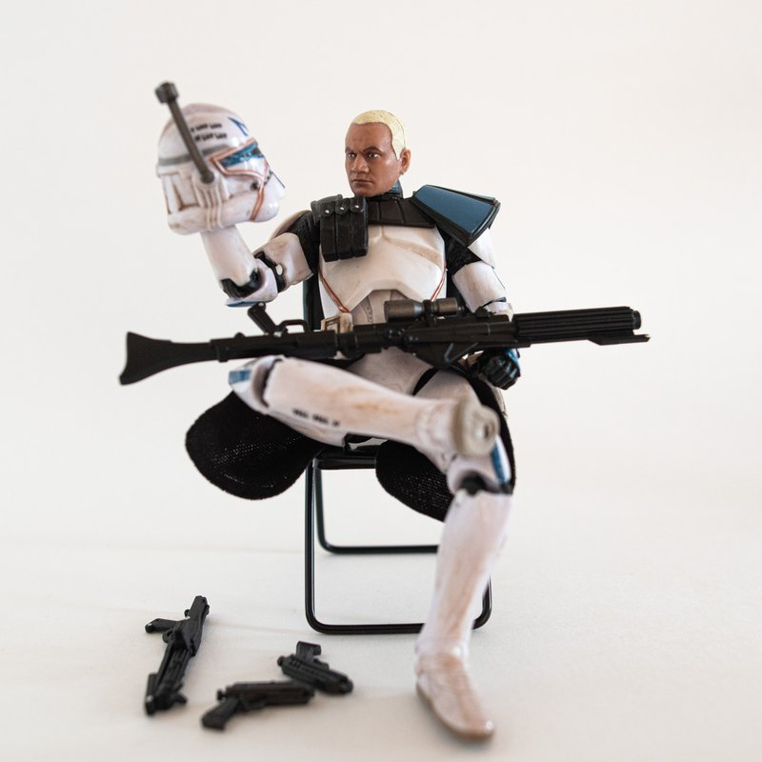Will Robots Replace Soldiers?
Some countries are already deploying robotic soldiers on the battlefields. For instance, the US has already recruited unmanned aerial military vehicles to drop missiles and conduct surveillance on unsuspecting terrorists attacking from overseas countries like Yemen and Pakistan.
The country is also one of the few that have deployed drones on the stateside to check on the citizens right from their homes. This has shown that the integration of virtual reality is also possible in the military. According to military officials, robotic soldiers are creating awesome co-working spaces with humans.
The morality and efficacy of robot technology in military operations seem to be controversial. Still, the proponents argue that the gadgets are inexpensive, reduce collateral damages, and save the American troops from risky operations.
The robots also don't require the payments for health insurance, thus proving the cost-effectiveness to the armies. The good part of it is that humans can command these machines right at the comfort and safety of the operation centers.
Some robots work far from the ground, but others operate on the ground in the battlefields. When the American forces were engaging with the Afghanistan and Iraq forces, they heavily relied on bomb-squad drones to inspect and defuse explosive devices set by the enemies. Human operators stayed safe a distance away while the robots moved via tank tread, floodlights, mechanical arms, and infrared vision to spot bombs and defuse them.
The US military forces applied the SWORDS (Special Weapons Observation Remote Reconnaissance Direct Action System) in 2005 when it went into action with Iraq. Alongside featuring light machine guns, the robots were highly mobile. Despite their mobility, the skittish military troops considered it wise to place them in fixed spots where they could protect the center's perimeters rather than have them run after the terrorists.
It's still undecided on whether armed bots are effective for autonomous shooting. According to military officials, the decision to use these deadly forces should be made by humans, not machines. But robotic soldiers are being developed to serve beyond playing the defense role.

What's the future of robot soldiers in wars?
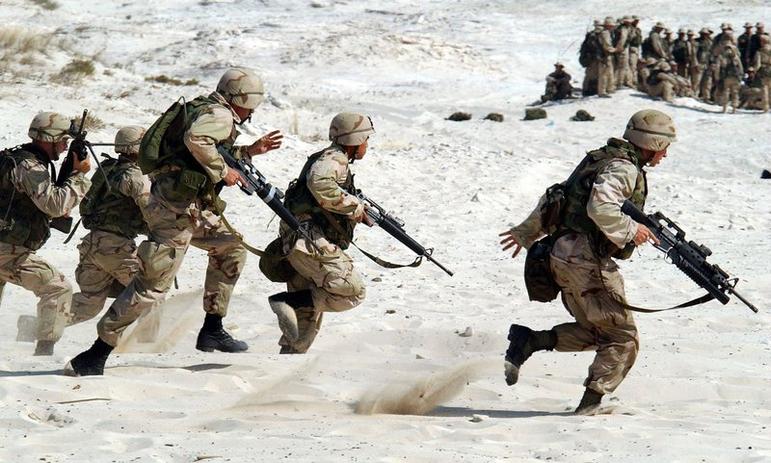 Will Robots Replace Soldiers: In War
A new breed of robots is still in the labs, and they are specially designed to accompany human soldiers to wars. Just like their human brethren, they can respond to voice and gesture commands. They can also carry and use lethal weapons like machine guns and grenade launchers.
A 159-kilogram MAARS (Modular Advanced Armed Robotic System) can run about $300,000 per pop, but supporters justify its cost by quoting its benefits if it replaces human soldiers. They say that it will not only cut down the costs, but it will also reduce physical risks and save human soldiers from emotional and mental issues like post-traumatic stress and anxiety that they often encounter during operations.
There is also the development of an animal-esque robot prototype that will enhance human soldiers' experiences by lightening their loads. The LS3(Legged Squad Support System) is a headless machine resembling a pack of horses or bulls. The robot is to complement human soldiers on the ground, rather than to replace them.
The aim here is to create a semi-autonomous robot that will carry at least 181 kilograms of military squad loads, accompany squad members through rugged terrains and interact with human troops naturally just like trained animals with their handlers.
The robotic soldiers will also minimize the need for the attendance register in military camps due to the reduced number of human soldiers in the operation centers. With these developments, we can agree that scientific engineering has contributed much to innovation and military expansion.

Bottom Line
Will robots replace soldiers? "Rocky VI ''features the themes of war-torn international relations, mortality, and performance-enhancing drugs by a little comic relief of "Sico," Balboa's family's robot. The robot interacts with humans, sings happy birthday songs to Uncle Paulie, and even refreshes him with an ice-cold beer.
The machine joins the family, and within two hours, Rocky slays a huge Russian boxer, avenges the death of his friend, and ends the cold war. Again we ask, will robots replace soldiers? This is a clear indicator that robotic soldiers will soon replace humans and may perform better than humans. We better get set to witness the robotic war in the future where we will have the robots replacing humans.

