How our Air Force might use Automation with Drones
If you read about the research forged by DARPA to automate our Air Force and use drones, here is what I understand is in our future plans. How soon these plans will be in play, is the only question. DARPA calls these mixture of piloted and drones "Mosaic Warfare."
Automated drones change the entire air battle situation dramatically. Automated drones are already used for surveillance and reconnaissance. One next mission for the automated drone is to fly wing for a piloted jet fighter. With additional software, drones in a varying numbers can fly in formation with one or more piloted jet fighters. That will greatly increase the effectiveness of our manned fighters by saturating, confusing and attacking air defense systems and easing final target approach. Drones can also be armed with rockets to attack enemy aircraft or ground targets.
Drones can also be used to accompany long range bombers, again to complicate the enemy defense systems by being very maneuverable decoys and even finish a drone's mission by attacking air defense systems or air defense locations.
They will also be very valuable to protect our future airborne decoy transporters that can be used to transport many decoys into the proximity of the target area where dozens of decoys can be launched support our offensive air operations. A large C-5, or C-17 transporter can be configured to transport dozens of decoys into the proximity of offensive air operations.
In terms of costs, drones are very cost effective. Without a pilot, and life support systems, drones will be developed much faster and much cheaper. Compared with the cost of an F-35 ($80 million), many drones will cost around $2 million. The maintenance crews for drones is miniscule compared to the teams of maintenance specialists who must support the life support systems for one or more pilots.
================================================================
SOURCES:
https://en.m.wikipedia.org/wiki/Kratos_XQ-58_Valkyrie
Kratos XQ-58 Valkyrie
The Kratos XQ-58 Valkyrie is an experimental stealthy unmanned combat aerial vehicle (UCAV) designed and built by Kratos Defense & Security Solutions for the United States Air Force Low Cost Attritable Strike Demonstrator (LCASD) program, under the USAF Research Laboratory’s Low Cost Attritable Aircraft Technology (LCAAT) project portfolio. It was initially designated XQ-222. The Valkyrie successfully completed its first flight on 5 March 2019 at Yuma Proving Ground, Arizona.[1]
XQ-58 Valkyrie
XQ-58A Valkyrie demonstrator first flight.jpg
The XQ-58A Valkyrie demonstrator on its inaugural flight, 5 March 2019 at Yuma Proving Ground, Arizona
Role
Unmanned combat aerial vehicle
National origin
United States
Manufacturer
Kratos Defense & Security Solutions
First flight
5 March 2019
Status
In development
Primary user
United States Air Force
Contents
Design and development

A XQ-58 Valkyrie deploys an Altius-600 unmanned aircraft system
The XQ-58 Valkyrie falls within the USAF Research Laboratory’s Low Cost Attritable Aircraft Technology (LCAAT) portfolio, whose objectives include designing and building Unmanned combat aerial vehicles (UCAVs) faster by developing better design tools and maturing and leveraging commercial manufacturing processes to reduce build time and cost.[1] The role of the LCAAT is to escort the F-22 or F-35 during combat missions, and to be able to deploy weapons or surveillance systems.[2][3]
The XQ-58 was designed to act as a "loyal wingman" that is controlled by a parent aircraft to accomplish tasks such as scouting, or absorb enemy fire if attacked. [4]
It must also be able to be deployed as part of a swarm of drones, with or without direct pilot control.
It features stealth technology with a trapezoidal fuselage with a chined edge, V-tail, and an S-shaped air intake.[3]
The first flight took place approximately 2.5 years from contract award. A total of five test flights are planned in two phases to evaluate system functionality, aerodynamic performance, and launch and recovery systems.[1]
On 23 July 2020, the Air Force awarded contracts to Kratos, Boeing, Northrop Grumman, and General Atomics authorizing the companies to compete for the Skyborg program, an effort to field an unmanned wingman cheap enough to sustain losses in combat but capable of supporting manned fighters in hostile environments; Kratos may use the XQ-58 as its submission, although it was developed separately under the Low Cost Attritable Strike Demonstrator (LCASD) program[5][6][7] and another airframe might be submitted.[8] Kratos was further down-selected, along with Boeing and General Atomics, on 7 December 2020. Submissions are to be delivered by May 2021 for flight tests in July 2021.[9][10]
On 26 March 2021, the XQ-58A completed its sixth test flight. It was the first time the payload bay doors were opened in-flight, and the first time ordnance - an Altius-600 small unmanned aircraft system - was released from the bay.[11]
Specifications
The second XQ-58 Valkyrie taking off from Laguna Army Airfield.
Data from [12]
General characteristics
Length: 28 ft 10 in (8.8 m)
Wingspan: 22 ft 0 in (6.7 m)
Performance
Maximum speed: 567 kn (652 mph, 1,050 km/h)
Maximum speed: Mach 0.85
Range: 2,128 nmi (2,449 mi, 3,941 km)
Service ceiling: 44,997 ft (13,715 m)
Armament
Hardpoints: 8: 2 weapon bays with 4 in each - with a capacity of up to 550 lb (250 kg),
Bombs: JDAM, Small diameter bomb
====================================================================
https://www.nationaldefensemagazine.org/articles/2018/9/14/the-future--of-air-power
New Age of Autonomous Jet Fighters on Horizon
9/14/2018, By Stew Magnuson, NATIONAL DEFENSE
The scenario military thinkers propose would double the number of jet fighters in a typical battle formation from four to eight. But instead of the additional aircraft being identical to an F-35 joint strike fighter, or F-15E Strike Eagle, they are low-cost, unmanned jets.
One might carry extra air-to-air missiles. Another may only have a sensor suite to boost situational awareness for the pilots in the traditional aircraft.
Whatever their payload, the enemy has to contend with double the number of targets on their radars. They have multiple “dilemmas” in front of them, giving U.S. forces an asymmetric advantage.
Further, shooting down one of the U.S. aircraft or jamming its communications links would not completely degrade the battle formation.
This scenario is part of a larger concept that has emerged from the Defense Advanced Research Projects Agency called “mosaic warfare.” Like a real mosaic that creates a picture out of smaller pieces, battlefield commanders can take disaggregated capabilities, sometimes in the form of low-cost, expendable robotic systems, to make life complicated for opponents.
“What does a platform have to do? It has to sense. It needs to communicate. It needs to defend itself. It needs to do data processing,” Jim Galambos, a DARPA program manager in the strategic technology office, said in an agency podcast.
“What if we disaggregate? What if I took the sensing function and put it on an unmanned system so it can be farther away?” It could be higher in the air to obtain a better angle of the battle. Or there could be multiple sensing platforms and angles, he said.
“Adversaries are pouring lots of money to go after single platforms that are high value. … Do I go after one of the sensors? I might get one but not all. And by the way, the main aircraft or ship is still going,” Galambos said.
Like a mosaic, the whole idea is to bring many pieces together through automation and communications links. If a few pieces are lost, “you still get the picture,” he said.
Or the pieces can be rearranged to tell a different story. Commanders can re-compose them and execute a different mission. Mosaic warfare is an attempt to bring together unmanned systems and manned systems, he said. Such systems are linked today but aren’t truly working together as a team.
Making this concept a reality in air warfare will require autonomous jets, a technology that is feasible now, experts said.
Kratos Defense, for example, has invested its own research-and-development dollars to adapt its jet aerial target system for other applications, said Steve Fendley, the company’s senior vice president and president of its unmanned systems division. It then went around to various U.S. military labs such as DARPA, the Air Force Research Laboratory and Defense Innovation Unit-Experimental to make the case that its jet target system can fill the capability gaps that slower, lower altitude unmanned aerial vehicles can’t.
“Because these systems have the fighter jet-type performance capability, they are also very well suited toward the contested environment that is such a challenge today for the military — both from the manned side and the unmanned side,” he said in an interview.
The company is touting two aircraft for unmanned applications: the XQ-58A Valkyrie and the Unmanned Tactical Aerial Platform-22 (UTAP-22).
Skip Stolz, director of strategic development for the autonomy, control and estimation group at BAE Systems, said his company has the software backbone that would allow autonomous jets to fly today — whether they are adapted from old fighters, or something built from a clean-sheet design.
“We have gone beyond where this is a technology problem,” Stolz said.
Software products such as its Mission Effectiveness Augmentation System build on almost two decades of work, mostly on DARPA programs.
There are some missions that the software doesn’t perform yet such as close-air support and proximity to friendly troops. But “that will be coming,” he said.
The challenges to fielding robotic jets don’t revolve around technology, but rather pilot trust and a lack of tactics development, he said.
“One of the main reasons we are talking about unmanned-manned teams is to take advantage of the strengths of the manned aircraft and to take advantage of the strengths of the unmanned aircraft,” he said.
Humans are very good at critical thinking and intuitive decision-making. Machines can’t hope to match a human doing that, or at least they won’t for a long time, Stolz said.
Machines are good at processing large amounts of data rapidly to help the pilot in the manned aircraft come to correct decisions without him or her being inundated with information, he added.
Retired Air Force Gen. Hawk Carlisle, former commander of Air Combat Command, and now president and CEO of the National Defense Industrial Association, predicted that there would be some kind of autonomous wingmen for jet fighters early in the next decade.
“Clearly that’s where we are headed. We have to be. We have to get more with less and one way to do that is to offload the stuff that can be offloaded to a machine,” he said.
He envisions a scenario in the not too distant future when an F-15E Strike Eagle deploys with four drones: one doing reconnaissance, one doing electronic warfare, one with munitions, and another a decoy.
If the enemy aims a radar at the decoy, it can autonomously maneuver in such a way that it causes confusion. If the EW drone senses a radar it can start jamming procedures. The recon drone gives the pilot better situational awareness as to what’s happening. The backseat pilot in the F-15E can monitor the drones.
“The idea is to give the adversary things he can’t handle,” Carlisle said. If you don’t know who is a shooter and who is a sensor, or if he can’t tell the difference between an automated penetrating [drone] and a B-21 bomber, then you’re giving him more problems.”
Meanwhile, lone F-22 and F-35 pilots can keep tabs of the drones themselves because fifth-generation aircraft are now automatically doing the basic flying and sensing tasks. In the older aircraft Carlisle flew earlier in his career, these tasks were “all done in your noggin.”
The fifth-gen jets manage all that “so you can raise the pilot to a higher level of achievement doing more and better things,” he said.
The other advantage is for contested environments, which the military has said repeatedly will define the battle zones of the future.
Opponents are going to try to jam communications, Carlisle said. They will not only go after aircraft, but space and cyber systems. Disaggregation creates resilience.
“What we have to do is be resilient and healing so we can continue the fight in a graceful degradation or a resilient mode,” he said.
Fendley said Kratos’ unmanned jets are ideal for contested environments because of their speed. Low-altitude unmanned systems are difficult to protect in a contested environment. The UTAP-22 flies at Mach 0.91 and the Valkyrie at Mach 0.72.
“The ability to apply these to the current mission sets that aren’t being satisfied from an unmanned perspective goes way up,” he said.
The Mitchell Institute for Aerospace Studies recently released a policy paper titled, “Manned-Unmanned Aircraft Teaming: Taking Combat Airpower to the Next Level.” The study encouraged the Air Force to pursue a partnering concept where a manned F-35 could potentially team up with F-16s converted to autonomous jets for a variety of missions. That could speed up decision-making, bring down costs and fill capability gaps until new purpose-built jets come online, it said.
“Thanks to advancements in autonomy, processing power and information exchange capabilities, the Air Force will soon be able to fly traditionally manned combat aircraft in partnership with unmanned aircraft,” the report said. “Approaching this opportunity in a graduated fashion with limited risk allows the operational community to explore new concepts of operation and tactics in an evolutionary fashion.”
Fendley said the Kratos aircraft could also fit the bill. Their roots as targeting aircraft meant they were built to be inexpensive and expendable.
The jet engine is the most costly single item. Meanwhile, the aircraft do not have to be certified for manned flight, which also drives down costs, he said.
“We started from a production capability and a design capability based on aerial target systems that — by requirement — must be very inexpensive,” he said. “That same design philosophy is being applied to our tactical systems.
“We’re developing airplanes that have fighter-like performance capabilities. They’re unmanned and incredibly inexpensive to acquire and operate and maintain,” he added.
Stolz advocated starting out with older model jets such as F-16s. To build pilot trust and develop the tactics needed to advance manned-unmanned teaming will require lots of flight hours and repetition, he said. A “safety pilot” could at first be in the unmanned aircraft’s cockpit to help build trust.
The software can then be inserted in a clean-sheet design aircraft and the pilots would immediately accept it, he said.
Carlisle didn’t think the trust issue was a major factor. “I don’t think there is a cultural reticence. People say, ‘Pilots don’t like [remotely piloted aircraft].’ That’s garbage. It’s just not true. These are great platforms doing great things that assist the fight.”
Stolz pointed out another advantage of the autonomous jets: it takes years to train human pilots to be expert flyers. “Once we have that software right, once we have those tactics developed, I don’t have to train my airplanes anymore. My unmanned airplanes are instantly at the same level of expertise.”
Air Force Research Laboratory Commander Maj. Gen. William Cooley, speaking at a Mitchell Institute event, said his organization is developing a common architecture and framework for autonomous jets so it can employ more advanced software and hardware systems rapidly. “Having that common architecture that allows us to integrate different capabilities is essential,” he said.
Developing prototypes and having the contracting authorities to conduct experiments will also be critical, he noted. “I think we’re poised to be able to do that, but we’ve got to start making it happen.”
While the idea of using previously retired combat aircraft to perform an unmanned “loyal wingman” mission certainly has merit, the service might also eventually consider a dedicated, low-cost platform, Cooley said.
AFRL will conduct some experiments with Kratos’ XQ-58A this fall, he added.
“The basic idea is can we make a capable, combat-type aircraft ... by using modern manufacturing techniques and drive the cost as low as possible,” he added.
==========================================
https://www.af.mil/News/Article-Display/Article/2563194/afrl-successfully-completes-xq-58a-valkyrie-flight-and-payload-release-test/

AFRL successfully completes XQ-58A Valkyrie flight and payload release test
By Air Force Research Laboratory Public Affairs / Published April 05, 2021
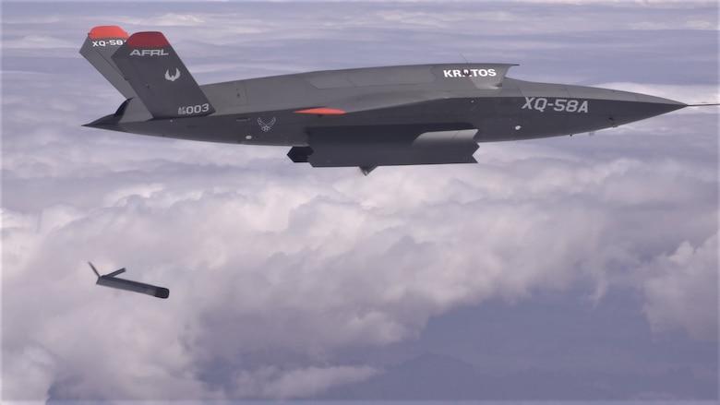
PHOTO DETAILS / DOWNLOAD HI-RES
The XQ-58A Valkyrie demonstrates the separation of the ALTIUS-600 small unmanned aircraft system in a test at the U.S. Army Yuma Proving Ground test range, Ariz., March 26, 2021. This test was the first time the weapons bay doors have been opened in flight. (U.S. Air Force courtesy photo)
WRIGHT-PATTERSON AIR FORCE BASE, Ohio (AFNS) --
The Air Force Research Laboratory successfully completed the XQ-58A Valkyrie’s sixth flight test and first release from its internal weapons bay, March 26 at Yuma Proving Ground, Arizona.
This test, conducted in partnership with Kratos Unmanned Aerial Systems (UAS) and Area-I, demonstrated the ability to launch an ALTIUS-600 small, unmanned aircraft system, or SUAS, from the internal weapons bay of the XQ-58A. Kratos, Area-I and AFRL designed and fabricated the SUAS carriage and developed software to enable release. After the successful release of the SUAS, the XQ-58A completed additional test points to expand its demonstrated operating envelope.
“This is the sixth flight of the Valkyrie and the first time the payload bay doors have been opened in flight,” said Alyson Turri, demonstration program manager. “In addition to this first SUAS separation demonstration, the XQ-58A flew higher and faster than previous flights.”
This test further demonstrates the utility of affordable, high performance unmanned air vehicles.
===============================
https://www.popularmechanics.com/military/a31122720/kratos-xq58a-valkyrie-future/

This Experimental Drone Could Change America's War Strategy
Is the Kratos XQ-58A Valkyrie the future of combat aircraft?
By Alex Hollings , Mar 17, 2020

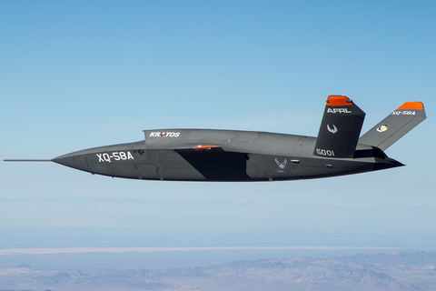
© Air Force/Senior Airman Joshua Hoskins
For nearly 20 years, the United States Air Force has been focused on anti-terror operations in uncontested airspace. Now, as America transitions its focus away from the War on Terror toward potential near-peer conflicts, the U.S. is looking to pull a page out of its own World War II playbook by building inexpensive combat aircraft that can overwhelm advanced enemy air defenses through sheer numbers.
The Kratos XQ-58A Valkyrie, an unmanned and experimental combat aerial vehicle, is tough to spot on radar and could be directly linked to the F-35 through an encrypted data connection to serve as a wingman under the pilot’s control. But even with these pros, it’s the cost of the Valkyrie, not its capabilities, that could change America’s aerial warfighting strategy.
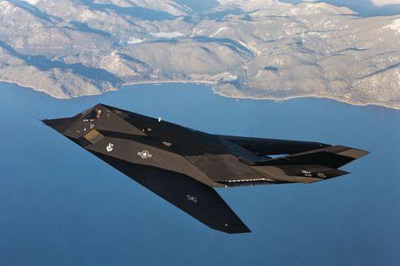
© Thiago Isvamsinsk via Flickr
While there’s no question the U.S. boasts the largest air force in the world in terms of total military aircraft, the makeup and size of that force has shifted dramatically since the final days of World War II. At that time, the U.S. boasted some 300,000 combat aircraft. Today, the nation has only around 13,400, spread out across its various military branches.
The reason for this change is the steady progress of technology, which has dramatically increased the combat capabilities and the cost of each aircraft in service today. These parallel developments in aviation production have resulted not only in a leaner, more capable Air Force, but a change in combat strategy altogether. Gone is the World War II mindset that called for superiority through volume. On today’s battlefield, it’s technology, not numbers, that makes the biggest difference.
But the capability gap offered by technology alone is difficult to maintain. As near-peer level opponents like China and Russia field more advanced air defense systems, America’s aircraft face the possibility of a more contested battle space than ever before. With American fighters costing upward of $80 million each, regardless of whether or not they possess stealth capabilities, each and every loss would be truly felt in a large-scale conflict. That’s why the strategic scales may be tipping back toward a force reliant on a high volume of aircraft, rather than the amount of tech that can be crammed into each one. And that’s where the Kratos XQ-58A Valkyrie could really shine.
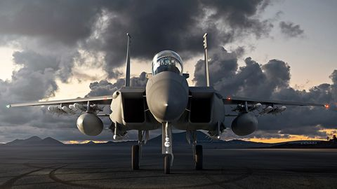
© Boeing
The Valkyrie has an internal weapon payload capacity of at least two small-diameter bombs and boasts a flight range of more than 2,000 miles, but more importantly, the Department of Defense (DoD) has a plan to connect these unmanned combat air vehicles (UCAVs) to F-35s and the new F-15EXs via encrypted data links to serve as support drones—an initiative known as the Skyborg program. These links, coupled with on-board artificial intelligence, will allow pilots of manned aircraft to control their drone wingmen, even sending them out ahead to relay sensor information back to the pilot.
That means the Valkyries would be able to engage ground targets on behalf of a manned fighter and potentially even sacrifice themselves to protect manned aircraft from inbound missiles.
“We can take risks with some systems to keep others safer,” Will Roper, Ph.D., assistant secretary of the Air Force for acquisition, technology, and logistics, told Defense News reporter Valerie Insinna last year.
Currently, combat aircraft rely on their own sensor suites to identify targets and potential threats, but with the Skyborg Program, unmanned aircraft could fly ahead to spot targets and relay data back to pilots. That would allow fighters to engage threats from further distances or avoid them all together.
“In the future, we can separate them out, put sensors ahead of shooters, put our manned systems behind the unmanned. There’s a whole playbook,” Roper told Defense News.
By using drone swarms, the U.S. hopes to overwhelm defensive systems.
All that capability comes with the tiny price tag (for jet-powered combat aircraft) of around $2 million per plane. Considering Raytheon’s single-use Tomahawk cruise missiles ring in at an estimated $1.4 million each and combat drones like the RQ-4 Global Hawk cost over $120 million apiece, $2 million for a reusable combat aircraft like the Valkyrie’s is a steal.
The Valkyrie’s low price tag lands it squarely within the DoD’s “attritable aircraft” concept—planes that are so cheap to replace that commanders can take greater risks with them without fearing their loss as much as they would a manned platform or even a high-dollar drone. As Kratos points out, the Valkyrie also offers “open architecture” that allows them to modify the aircraft to suit different mission requirements with different payload options. This dramatically increases the number of mission types these drones can support, including air-to-air and air-to-ground engagements.
A shift toward producing a large number of these “attritable” platforms could offer a huge boost in America’s air power capabilities by returning to overwhelming force through volume. That’s important, because despite how advanced air defense systems have become, they still have a limited magazine. By using drone swarms, the U.S. hopes to overwhelm defensive systems, which is a big part of why the Air Force is emphasizing the “attritable” part of its drone program.
"Swarming allows you to build large numbers of low-cost expendable agents that can be used to overwhelm an adversary," Paul Scharre, from the Center for a New American Security think tank, told BBC News’ Thomas McMullan last year. "This reverses the long trend of rising aircraft costs and reducing quantities.”
Unlike in the days of World War II, however, the value of all those aircraft can be bolstered further by the advanced data collection and leveraging capabilities of flying supercomputers like Lockheed Martin’s F-35 Joint Strike Fighter.
A decision on whether the Pentagon wants to move forward with mass production of the Valkyrie is expected to come as soon as 2021. (Since it’s a new platform that’s still in testing, there’s always the chance that new problems will emerge.) But regardless of that decision, it looks as though the future of air superiority will likely look an awful lot like this new Kratos drone.
As air defenses continue to mature, stealth won’t be enough to dominate the airspace above a battle, and that’s where old fashioned arithmetic may be the only route to victory. By sending more low-cost and unmanned aircraft at a target than the surrounding defenses can effectively engage, Skyborg drones can assure victory even when stealth can’t get the job done.
With both Russia and China reportedly developing their own “wingman” drones, the wars of the future may well be won through overwhelming air defense systems with swarms of armed UCAVs taking their cues from nearby human pilots.

