A Difference of Opinion
During the past two years, some senior politicians and other officials have declared that China was our major enemy, and an existential threat to America. It is now Russia.
In recent times (past 4 years), we have heard White House cabinet officers and senior military officers declare China to be our major enemy. General Joseph Dunford, chairman of the Joint Chiefs of Staff, declared that “China probably poses the greatest threat to our nation by 2025.” US Trade Representative Robert Lighthizer stated that China was an existential threat to America.
It's 2021, the U.S. intelligence committee, reflecting on Russian President Vladimir Putin's unsuccessful attempts to influence our 2020 Presidential election, now declare that "Moscow is the biggest threat to national security." After his election victory, Biden did declare Russia as Washington's most serious global threat in an interview with CBS's 60 Minutes in October 2020.
What changed? Apparently, Russian hackers, supporting Donald Trump were relatively more effective during our 2016 election. Their 2019-2020 hacking work was not very effective targeting Presidential candidate, Joe Biden. It is surprising to many that there were no allegations of Chinese efforts to influence our Election.
Source: https://mobile.reuters.com/article/amp/idUSKBN27B13B
==================================================================
Kremlin accuses Joe Biden of spreading hatred of Russia with threat talk
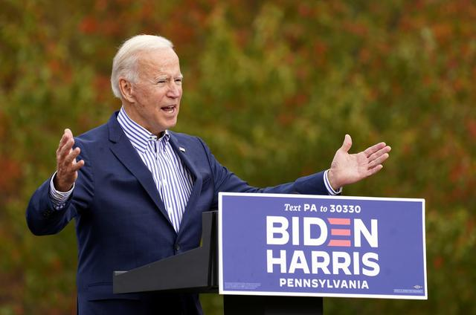
FILE PHOTO: U.S. Democratic presidential candidate Joe Biden speaks during a drive-in campaign event at Bucks County Community College in Bristol, Pennsylvania, U.S., October 24, 2020.
Reuters/Kevin Lamarque
(Reuters) - The Kremlin said on Monday that U.S. Democratic presidential challenger Joe Biden's assessment of Russia as the biggest threat to U.S. national security was wrong and encouraged hatred of Russia.
The comments come just over a week before Biden faces Donald Trump in the Nov. 3 U.S. presidential election. Biden is ahead in the polls.
"We absolutely do not agree," Kremlin spokesman Dmitry Peskov told reporters on a conference call, when asked to comment on Biden's assessment.
"We can only regret that absolute hatred of the Russian Federation is spread in this way."
Moscow's ties with Washington sank to post-Cold War lows in 2014 when Russia annexed Crimea from Ukraine. Biden was serving as vice president under President Barack Obama at the time.
Relations were further soured after U.S. intelligence agencies concluded that Russia tried to interfere in the 2016 U.S. presidential election to tilt the contest in Trump's favour, an allegation Moscow has denied.
Russia has also dismissed accusations by U.S. intelligence agencies of trying to interfere with this year's election.
Biden named Russia as Washington's most serious global threat in an interview with CBS's 60 Minutes on Sunday, while calling China the biggest competitor.
"Well, I think the biggest threat to America right now in terms of breaking up our security and our alliances is Russia," said Biden.
Putin, who has praised Trump in the past for saying he wanted better ties with Moscow, has said Russia will work with any U.S. leader, while noting what he called Joe Biden's "sharp anti-Russian rhetoric".
The Russian leader said on Sunday that he saw nothing criminal in past business ties with Ukraine or Russia developed by Biden's son Hunter, marking out his disagreement with one of Trump's attack lines in the U.S. election.
Analysts say Putin's behaviour looks like he is hedging his bets on who wins the U.S. election.
(Reporting by Dmitry Antonov; writing by Tom Balmforth; editing by Andrew Osborn)

