Chinese Sail their Shandong aircraft carriers into the Taiwan Strait.

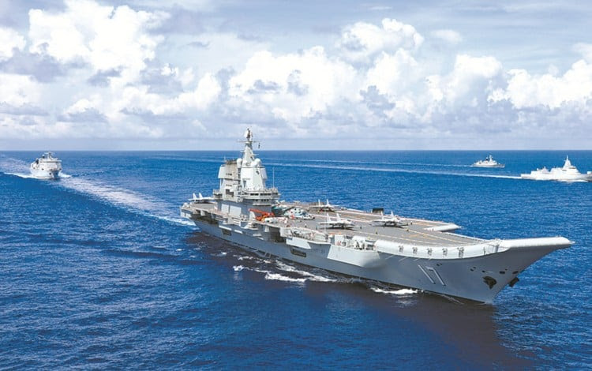

Chinese show of force follows after US and Canadian warships sail across the Taiwan Strait.

A strong Chinese show of force, a pattern of military action was repeated on September 11, 2023, two days after the western navy ships exercised their freedom of sea rights. These Chinese reactions have been consistent for several years after Congresswoman Nancy Pelosi visited Taiwan. The size of the Chinese military reaction has increased each time they have reacted to an American that might support Taiwanese independence inclinations.

As long as no accidents happen, deliberate or otherwise, a conflict is avoided. The leadership of both China and America realize that a conflict between the most powerful nations in the world would be very bad for both sides.

=====================================================

SOURCE:

PLA aircraft carrier Shandong makes Taiwan ‘show of force’ days after US, Canadian warships cross Taiwan Strait

- The Shandong sailed just 60 nautical miles off Taiwan’s southernmost tip, island’s defense ministry says in statement on Monday
- Sail-by comes after US and Canadian warships carry out Taiwan Strait freedom of navigation crossing condemned by the PLA
Lawrence Chung, in Taipei, SCMP, September 11, 2023

The People’s Liberation Army aircraft carrier Shandong sailed just 60 nautical miles (111km) off Taiwan’s southernmost tip in what is being viewed as a fresh show of force as tensions escalate in the region.
The passage, cautiously monitored by the Taiwanese military, came two days after the PLA condemned a Taiwan Strait transit by US and Canadian warships as an open challenge to Beijing’s claim that the channel is an internal waterway.
The warship was apparently accompanied by more than a dozen PLA aircraft, according to the Taiwanese defence ministry, which reported sighting the Shandong near the island earlier on Monday.
“A naval formation led by the Shandong was spotted passing 60 nautical miles off the southeast tip of Oluanpi and sailing eastward towards the western Pacific for training,” the ministry said in a statement, referring to the southernmost point on the island of Taiwan.
It was the first time the Shandong had come so close to the island.
The warship has sailed through the Taiwan Strait several times and was reported in April to have been spotted 200 nautical miles off Oluanpi on its way to the western Pacific for training in April.

Chinese carrier sails through Taiwan Strait days after Blinken visit on June 21 2023

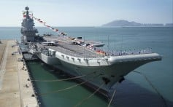

A total of 13 PLA warplanes, including J-16 and Su-30 fighter jets and Shaanxi KJ-500 early warning aircraft, were also detected earlier on Monday as the Shandong passed southern Taiwan, the ministry said.
Of the sorties, 11 crossed the de facto median line separating the island and the mainland in the Taiwan Strait and some entered the island’s southwest air defence identification zone (ADIZ), it said.
In addition, 26 PLA warplanes and 13 warships were detected around Taiwan during the 23 hours from 6am on Sunday to 5am on Monday, the ministry said, with 11 found to have breached the median line and entered Taiwan’s southwestern ADIZ.

Six J-16 fighter jets were detected to have flown along the median line from east to west and from west to east in a rare flight mode that could pose a new challenge to the island’s military.
The Taipei ministry said it had immediately “sent warplanes and warships to shadow the PLA movements and deployed missile systems as appropriate responses”.
The PLA has ramped up pressure on Taiwan over the past year, by first sending warplanes to Taiwan’s southwestern ADIZ, then crossing the median line and entering the southeastern ADIZ. In recent months, it has even sent drones to circle the island.
The Shandong, the PLA’s second aircraft carrier, was commissioned in 2019. Its sail-by in April came as the warship participated in mega military drills after Taiwanese President Tsai Ing-wen met US House Speaker Kevin McCarthy during a stopover in California.
Beijing considered the high-level exchange a violation of its sovereignty and a breach of Washington’s one-China policy, just as it did the visit to Taipei by McCarthy’s predecessor Nancy Pelosi in August last year.
China’s military simulates precision strikes on Taiwan after island’s leader returns from US visit
Beijing, which views Taiwan as its territory and has not renounced the use of force to bring it under control, staged a series of unprecedented live-fire drills around Taiwan to intimidate the island shortly after Pelosi’s visit.
Most countries, including the United States, do not recognise Taiwan as an independent state but are opposed to any unilateral change of the cross-strait status quo by force.
Su Tzu-yun, a senior analyst at the Institute for National Defence and Security Research, a government-funded think tank in Taipei, said the sail-past by the Shandong was obviously a show of force by the PLA in response to the strait passage by US and Canadian warships on Saturday.
The US Navy’s 7th Fleet said the guided-missile destroyer USS Ralph Johnson and Canada’s HMCS Ottawa conducted a “routine” transit “through waters where high-seas freedoms of navigation and overflight apply in accordance with international law”.
The PLA Eastern Theatre Command, which oversees the area, later condemned the passage as an open challenge to Beijing’s claim over the strait.
Su said the Shandong was more combat-ready than before as shown by its recent movements and long-range training in the western Pacific.
“[Monday’s sail-by] was also a show of force in response to the recent live-fire Super Garuda Shield drills that involved 19 countries, including the United States and Indonesia,” Su said.
It was also one way for Beijing to distract public attention from the grim economic situation at home, he added.
The Super Garuda Shield drills, launched on August 31, bring together seven participating and 12 observing nations for a two-week combined joint multi-lateral exercise.
Chieh Cheng, a security analyst at the National Policy Foundation, a Taipei think tank affiliated with the main opposition Kuomintang party, said the rare flight mode adopted by the six J-16s along the median line was intended to put further pressure on the island.
He too thought the PLA moves were “a response to the transit through the Taiwan Strait by the US destroyer and the Canadian frigate”.

