https://amp.cnn.com/cnn/2018/04/26/asia/north-korea-nuclear-test-site-punggye-ri-intl/index.html
North Korea's nuclear test caused collapse, study says
By Joshua Berlinger and Serenitie Wang, CNN, April 26, 2018
(CNN) North Korea's nuclear test in September last year was so strong that it caused an on-site collapse at the test site, geologists in China claim.
Using high-quality seismic data to pinpoint the location of several tremors that followed the test, the researchers determined that one event 8.5 minutes after the nuclear test was in fact the cavity caused by the blast collapsing.
The site that reportedly collapsed is just one part of the sprawling Punggye-ri complex, which is believed to include a series of tunnels, some of which burrow below other mountains.
The nuclear test, North Korea's sixth, was the country's most powerful to date.
The findings come from a research team at the China University of Science and Technology, whose work was accepted for publication by the academic journal Geophysical Research Letters.
The study's lead author, Wen Lianxing, warned that if North Korea were to use the same area for another test it could cause an "environmental catastrophe."
"North Korea's past tests have altered the tectonic stress in the region to the extent that previously inactive tectonic faults in the region have reached their state of critical failure. Any further disturbance from a future test could generate earthquakes that may be damaging by their own force or crack the nuclear test sites of the past or the present," Wen said in a statement.
Test site to be shuttered
The international community and Beijing in particular have long been concerned that an accident or radiation leak at the site could have consequences across the border.
Punggye-ri is fewer than 100 miles (160 kilometers) away from China, and residents living along the border said they felt the powerful tremor caused by September's nuclear test.
North Korean leader Kim Jong Un said last week that he was ordering the test site to be shuttered, declaring that North Korea no longer needed to test nuclear weapons. Though the move was viewed by some as a good will gesture ahead of his historic summit Friday with South Korean President Moon Jae-in, others said it showed a level of confidence in North Korea's nuclear program.
"They're basically talking the talk of advanced nuclear powers. Advanced nuclear weapons states, they don't have to conduct tests anymore because they've reached that level," said Duyeon Kim, a visiting senior fellow at the Korean Peninsula Future Forum and columnist at the Bulletin of the Atomic Scientists.
Details about the happenings at Punggye-ri are nearly possible to corroborate independently.
North Korea is closed off to most foreigners and rarely releases details about its secretive nuclear program, and never if they are negative.
But reports of significant issues at the Punggye-ri test site due to the sixth nuclear test have trickled out anyway.
Satellite imagery supplied to the Arms Control Wonk blog showed the explosion from the nuclear test visibly displaced the mountain.
And Japan's TV Asahi reported last year that a collapse at the tunnel site shortly after the test possibly killed more than 200 people, citing unnamed sources close to North Korea. CNN and other western media outlets were unable to confirm those reports.
Citing commercial satellite imagery, the North Korea monitoring website 38 North observed late last year what it described as "significant tunneling operations" at a portal that has yet to be used.
The site also reported some recent unusual activity at the site, but concluded it was too early to say if it was related to current political developments.
============================================================

https://amp.scmp.com/news/china/diplomacy-defence/article/2143171/north-koreas-nuclear-test-site-has-collapsed-and-may-be-why-kim-jong-un

North Korea’s nuclear test site has collapsed ... and that may be why Kim Jong-un suspended tests

The mountain’s collapse after a fifth blast last fall has led to the creation of a massive ‘chimney’ that could leak radioactive fallout into the air, researchers have found
Stephen Chen , Published: 3:45pm, 25 Apr, 2018

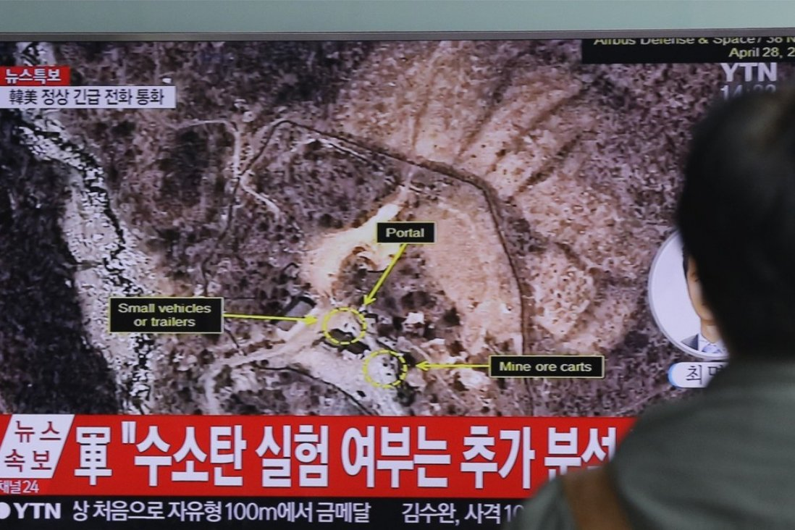
North Korea’s mountain site has collapsed, putting China and other nearby nations at unprecedented risk of radioactive exposure, two separate groups of Chinese scientists studying the issue have confirmed.
The collapse after five nuclear blasts may be why North Korean leader Kim Jong-un declared on Friday that he would
The last five of Pyongyang’s six nuclear tests have all been carried out under Mount Mantap at the Punggye-ri nuclear test site in North Korea’s northwest.

Chinese scientists warn North Korea about disaster threat at nuclear test site
One group of researchers found that the most recent blast tore open a hole in the mountain, which then collapsed upon itself. A second group concluded that the breakdown created a “chimney” that could allow radioactive fallout from the blast zone below to rise into the air.
A research team led by Wen Lianxing, a geologist with the University of Science and Technology of China in Hefei, concluded that the collapse occurred following the detonation last autumn of North Korea’s most powerful thermal nuclear warhead in a tunnel about 700 metres (2,296 feet) below the mountain’s peak.
The test turned the mountain into fragile fragments, the researchers found.
The mountain’s collapse, and the prospect of radioactive exposure in the aftermath, confirms a series of exclusive reports by the South China Morning Post on China’s fears that Pyongyang’s latest nuclear test had caused a fallout leak.
Radioactive dust could escape through holes or cracks in the damaged mountain, the scientists said.
“It is necessary to continue monitoring possible leaks of radioactive materials caused by the collapse incident,” Wen’s team said in the statement.
Every Saturday
SCMP Global Impact Newsletter
By submitting, you consent to receiving marketing emails from SCMP. If you don't want these, tick here
By registering, you agree to our T&C and Privacy Policy
The findings will be published on the website of the peer-reviewed journal, Geophysical Research Letters, likely next month.
North Korea saw the mountain as an ideal location for
North Korea saw the mountain as an ideal location for underground nuclear experiments because of its elevation – it stood more than 2,100 metres (6,888 feet) above sea level – and its terrain of thick, gentle slopes that seemed capable of resisting structural damage.

North Korea suspends nuclear and missile tests

The mountain’s surface had shown no visible damage after four underground nuclear tests before 2017.
But the 100-kilotonne bomb that went off on September 3 vaporised surrounding rocks with unprecedented heat and opened a space that was up to 200 metres (656 feet) in diameter, according to a statement posted on the Wen team’s website on Monday.
As shock waves tore through and loosened more rocks, a large section of the mountain’s ridge, less than half a kilometre (0.3 mile) from the peak, slipped down into the empty pocket created by the blast, leaving a scar visible in satellite images.
Wen concluded that the mountain had collapsed after analysing data collected from nearly 2,000 seismic stations.

Kim Jong-un boasts of ‘death-defying struggle’ to build arsenal

Three small earthquakes that hit nearby regions in the wake of the collapse added credence to his conclusion, suggesting the test site had lost its geological stability.
Another research team led by Liu Junqing at the Jilin Earthquake Agency with the China Earthquake Administration in Changchun reached similar conclusions to the Wen team.

https://www.express.co.uk/news/world/873443/north-korea-nuclear-accident-Punggye-ri-tunnel-collapse-kim-jong-un/amp

North Korea nuclear accident: Fears grow of Chernobyl-type disaster as 200 die in collapse
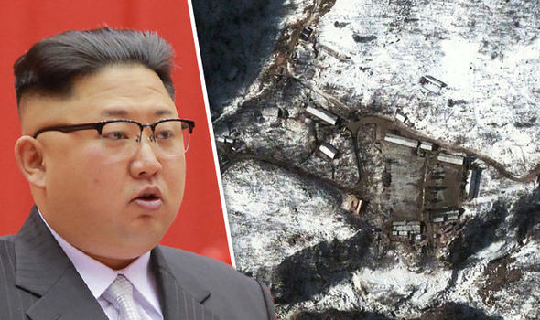GETTY
North Korea news: 200 people have died following an accident at a nuclear testing facility

NORTH Korea has been hit by tragedy after 200 nuclear workers died in an accident at despot Kim Jong-un's main testing facility .
By Joey Millar, Wed, Nov 1, 2017

North Koreas Punggye-ri facility has suffered a devastating collapse, leaving around 200 people dead.
Around 100 people were killed when when an unfinished tunnel collapsed at Kim Jong-un's main nuclear testing site.
Another 100 people subsequently died while attempting to rescue the first group of entombed workers.
Foreign experts had warned a collapse was likely, highlighting the danger of a cloud of radioactive fallout escaping from the site and spreading across "an entire hemisphere".
The disaster was revealed by Japan’s TV Asahi today, although they could not clarify when the accident and subsequent doomed rescue attempts took place.
They said North Korean sources told them the collapse occurred as workers were working on the new tunnel. A second collapse took place as workers tried to rescue their colleagues.
Punggye-ri was the site of North Korea’s sixth-ever nuclear test on September 3. They tested a huge 100-kiloton explosive which was around seven times as powerful as the bomb dropped on Hiroshima during WW2.
This test is blieved to have badly destabalised the mountainside-based facility.
Speculation is now growing the tragedy could bring a halt to Kim Jong-un's nuclear ambitions, which he hoped would see the hermit nation rival the capabilities of America.
Pyongyang is supposed to be the showcase of North Korea, so building exteriors are carefully maintained. When you get a rare chance to look inside, the bleak truth becomes apparent
Eric Lafforgue/Exclusivepix Medi
Foreign experts and human rights activists had warned this month, however, of the danger of despot Kim Jong-un’s crumbling facilities.
North Korea’s detonated its first ever H-bomb in September, causing serious damage to the facility’s foundations.
Subsequent small earthquakes have since indicated the area was becoming increasingly unstable.
The Punggye-ri test site is built into Mount Mantap, extending deep within the mountain.
While the exact locations of the nuclear tests themselves remain a mystery, seismologists believe they can pinpoint it to a 100 metre area.
While a test site could be operate safely at such a location, unsophisticated engineers are believe to have increased the risk of disaster with crude drilling techniques.
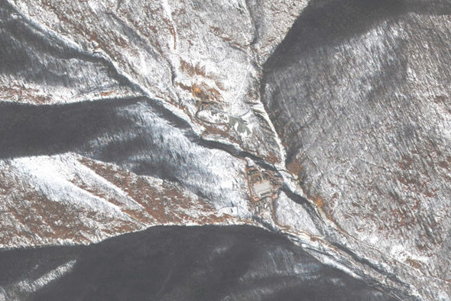
North Korea news: A satellite image of the Punggye-ri facility

China issued a dire warning to Kim regarding the state of the nuclear testing site.
They said a cloud of nuclear fallout could spread across "an entire hemisphere" if the facility collapsed.
The Chinese Academy of Sciences’ Institute of Geology and Geophysics warned: “China cannot sit and wait until the site implodes.
"Our instruments can detect nuclear fallout when it arrives, but it will be too late by then.
“There will be public panic and anger at the government for not taking action.”
============================================================

2017 North Korean nuclear test - Wikipedia
The Democratic People's Republic of Korea (North Korea) conducted its sixth (and most recent to date) nuclear test on 3 September 2017, stating it had tested a thermonuclear weapon (hydrogen bomb).^{[6]} The United States Geological Survey reported an earthquake of 6.3-magnitude not far from North Korea's Punggye-ri nuclear test site.^{[7]} South Korean authorities said the earthquake seemed to be artificial, consistent with an underground nuclear test.^{[8]} The USGS, as well as China Earthquake Networks Center, reported that the initial event was followed by a second, smaller, earthquake at the site, several minutes later, which was characterized as a collapse of the cavity formed by the initial detonation.^{[9][10]}
2017 North Korean nuclear test
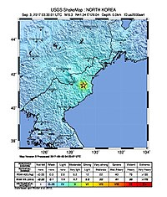
Graphic from the United States Geological Survey showing the location of seismic activity at the time of the test
Information
Country | North Korea
Test site | 41.343°N 129.036°E^{[1]}  Punggye-ri Nuclear Test Site, Kilju County
Period | 12:00:01, 3 September 2017 UTC+08:30 (03:30:01 UTC)^{[1]}
Number of tests | 1
Max. yield | ~50 kilotons of TNT (210 TJ) based on Korea Meteorological Administration^{[2]} -  ~260 kilotons of TNT (1,100 TJ) based on ISRO synthetic-aperture radar analysis^{[3]}
Test chronology
← September 2016 test

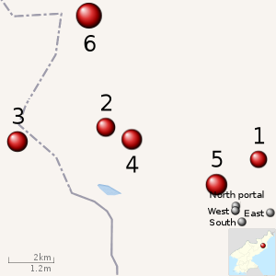
[Interactive fullscreen map]
Location of North Korea's Nuclear tests^{[4][5]}
1: 2006; 2: 2009; 3: 2013; 4: 2016-01; 5: 2016-09; 6: 2017;
V

Contents

Nuclear device
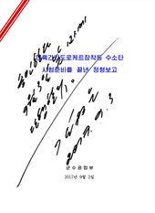
Order to conduct the test, signed by Kim Jong-un on 3 September 2017
The North Korean government announced that it had detonated a hydrogen (thermonuclear) bomb that could be loaded onto an intercontinental ballistic missile (ICBM).^{[11]} The announcement stated the warhead had a variable yield "the explosive power of which is adjustable from tens kiloton to hundreds kiloton (sic) ... [and] which can be detonated even at high altitudes for super-powerful EMP attack".^{[12]} A later technical announcement called the device a "two-stage thermo-nuclear weapon" and stated experimental measurements were fully compatible with the design specification, and there had been no leakage of radioactive materials from the underground nuclear test.^{[13][6]}
Analysts have tended to give credence to North Korea's claim that it was a hydrogen bomb.^{[15][16]} 38 North made a revised estimate for the test yield at 250 kT, making it near the maximum-containable yield for the Punggye-ri test site.^{[17]} Tom Plant, director of proliferation and nuclear policy at the Royal United Services Institute said, "The North Koreans do bluff sometimes, but when they make a concrete claim about their nuclear programme, more often than not it turns out to be true. ... I think the balance is in favour of it being a thermonuclear bomb rather than a conventional atom bomb."^{[18]}
Others have been skeptical that it was a completely successful test of a true hydrogen bomb as North Korea claimed. Determining whether it is a two-stage thermonuclear bomb or a fusion-boosted fission weapon may not be possible without radionucleide emission data.^{[19][16]} The yield estimates of less than 300 kT would be lower than any other nation's first test of a fusion-primary thermonuclear device, which would typically be in the 1000 kT range, while boosted fission weapons and variable-yield nuclear devices can be as low as hundreds of tons, but are not considered true hydrogen bombs; meanwhile the largest pure-fission bomb tested was Ivy King at 500 kT.^{[20][better source needed]} An October 2 Scientific American article said the test was "estimated to have been a 160-kiloton detonation — far below an H-bomb's capabilities."^{[21]} Martin Navias of the Centre for Defence Studies at King's College London noted that the breakthroughs needed to get from a fission to a fusion device would have to be done by the North Koreans on their own – China, Russia, Pakistan, and Iran would not or could not help.^{[18]}
Jane's Information Group estimates a North Korean thermonuclear Teller-Ulam type bomb would weigh between 250–360 kilograms (550–790 lb). ^{[22]}
As of January 2018 there have been no official announcements from the United States confirming or contradicting the detonation of a hydrogen bomb. However, on 15 September 2017 John E. Hyten, head of U.S. Strategic Command, said, "When I look at a thing this size, I as a military officer assume that it's a hydrogen bomb."^{[23]}

Yield estimates
On the day of the test the chief of the South Korean parliament's defense committee, Kim Young-Woo, stated the nuclear yield was equivalent to about 100 kilotons of TNT (100 kt): "The North's latest test is estimated to have a yield of up to 100 kilotons, though it is a provisional report."^{[24]} The independent seismic monitoring agency NORSAR estimated that the blast had a yield of about 120 kilotons, based on a seismic magnitude of 5.8.^{[25]}
On 4 September, the academics from the University of Science and Technology of China^{[26]} released their findings based on seismic results and concluded that the nuclear test occurred at 41°17′53.52″N 129°4′27.12″E at 03:30 UTC, only a few hundred meters from the four previous tests (2009, 2013, January 2016 and September 2016) with the estimated yield at 108.1 ± 48.1 kt.
On 5 September, the Japanese government gave a yield estimate of about 160 kilotons, based on analysing Comprehensive Nuclear-Test-Ban Treaty Organization seismic data, replacing an early estimate of 70 kilotons.^{[27]}
On 6 September, an early assessment by U.S. Intelligence that the yield was 140 kilotons, with an undisclosed margin of error, was reported.^{[28]} On 13 September, U.S. Intelligence was reported referring to an early yield estimate range of 70 to 280 kilotons made by the Air Force Technical Applications Center.^{[29]}
On 12 September, NORSAR revised its estimate of the earthquake magnitude upward to 6.1, matching that of the CTBTO, but less powerful than the USGS estimate of 6.3. Its yield estimate was revised to 250 kilotons, while noting the estimate had some uncertainty and an undisclosed margin of error.^{[30][31]}
On 13 September, an analysis of before and after synthetic-aperture radar satellite imagery of the test site was published suggesting the test occurred under 900 metres (3,000 ft) of rock and the yield "could have been in excess of 300 kilotons".^{[32]}
In October 2019 a paper by the Indian Space Research Organization was published using satellite interferometric synthetic-aperture radar data to analyse surface deformations using Bayesian modelling to reduce uncertainties. It found that the explosion depth was 542 ± 30 metres below Mount Mantap, and the yield was 245–271 kilotons.^{[3][33]}

Reactions

The United Nations Security Council met in an open emergency meeting on 4 September 2017, at the request of the US, South Korea, Japan, France and the UK.^{[34]}
Canada, China, Indonesia, Japan, Malaysia, the Philippines, Russia, Singapore, South Korea, and the United States voiced strong criticism of the nuclear test.^{[35][36][37][38][39]}
US President Donald Trump wrote on Twitter: "North Korea has conducted a major nuclear test. Their words and actions continue to be very hostile and dangerous to the United States".^{[40][41]} Trump was asked whether the U.S. would attack North Korea and replied: "We'll see."^{[42]} Defense Secretary James Mattis warned North Korea that it would be met with a "massive military response" if it threatened the United States or its allies.^{[43]}

References
• "M 6.3 Explosion – 22 km ENE of Sungjibaegam, North Korea". USGS. 3 September 2017. Archived from the original on 3 September 2017. Retrieved 3 September 2017.
• • "North Korea nuclear test: what we know so far". Guardian. 3 September 2017.
• • K M Sreejith; Ritesh Agrawal; A S Rajawat (January 2020). "Constraints on the location, depth and yield of the 2017 September 3 North Korean nuclear test from InSAR measurements and modelling". Geophysical Journal International. Oxford University Press. 220 (1): 345–351. doi:10.1093/gji/ggz451. Retrieved 15 November 2019.
• • "Search Results". USGS.
• • "North Korea's Punggye-ri Nuclear Test Site: Analysis Reveals Its Potential for Additional Testing with Significantly Higher Yields". 38North. 10 March 2017.
• • Kemp, Ted (3 September 2017). "North Korea hydrogen bomb: Read the full announcement from Pyongyang". CNBC News. Retrieved 5 September 2017.
• • "North Korea confirms sixth nuclear test". CNN. 3 September 2017. Retrieved 3 September 2017.
• • "North Korea conducts another nuclear test, neighbors say". The Washington Post. 3 September 2017. Retrieved 3 September 2017.
• • "North Korea claims successful hydrogen bomb test". Deutsche Welle. 3 September 2017. Retrieved 3 September 2017.
• • "North Korea nuclear test: 'Tunnel collapse' may provide clues". BBC News. 3 September 2017. Retrieved 3 September 2017.
• • "North Korea says it successfully tested hydrogen bomb, marking sixth nuclear test since 2006". ABC News. 3 September 2017. Retrieved 3 September 2017.
• • "Sixth Nuclear Test Detected at Punggye-ri, Declared to be a Hydrogen Bomb". 38 North. U.S.-Korea Institute, Johns Hopkins University School of Advanced International Studies. 3 September 2017. Retrieved 5 September 2017.
• • Ankit Panda, Vipin Narang (5 September 2017). "Welcome to the H-Bomb Club, North Korea". The Diplomat. Retrieved 5 September 2017.
• • Hanham, Melissa (3 September 2017). "Kim inspects 'nuclear warhead': A picture decoded". BBC News. Retrieved 3 September 2017.
• • Albert, Eleanor (3 January 2018). "North Korea's Military Capabilities". Council on Foreign Relations. Retrieved 12 March 2018.
• • Sample, Ian (4 September 2017). "Did North Korea just test a hydrogen bomb?". The Guardian. Retrieved 12 March 2018.
• • Pabian, Frank V; Bermudez, Joseph S Jr; Liu, Jack (12 September 2017). "North Korea's Punggye-ri Nuclear Test Site: Satellite Imagery Shows Post-Test Effects and New Activity in Alternate Tunnel Portal Areas". 38 North. US-Korea Institute at Johns Hopkins SAIS. Retrieved 12 March 2018.
• • Freeman, Colin (28 September 2017). "North Korea: How did a small, dirt-poor pariah state build its own H-bomb?". The Daily Telegraph. Retrieved 12 March 2018. The Chinese wouldn't help them today, nor would the Russians, and neither Pakistan nor Iran have the necessary level of expertise. ... I would say they've done it independently, just moving forward a bit at a time
• • "North Korea Nuclear Technology & Nuclear Weapons Program". James Martin Center for Nonproliferation Studies at the Middlebury Institute of International Studies at Monterey. NTI. 2017. § "Recent Developments and Current Status". Retrieved 12 March 2018.
• • Carey Sublette, ed. (14 October 2006). "Complete List of All U.S. Nuclear Weapons". Nuclear Weapons Archive. Retrieved 12 March 2018.
• • Greenemeier, Larry (2 October 2017). "Known Unknowns: The Dangers of North Korea's H-Bomb Threat". Scientific American. Retrieved 12 March 2018. While this assertion appears to be the author's, it is preceded and followed with quotations from Edwin Lyman of the Union of Concerned Scientists' Global Security Program.
• • http://www.janes.com/images/assets/111/75111/North_Korea_bargains_with_nuclear_diplomacy.pdf
• • "U.S. nuclear commander assumes North Korea tested H-bomb Sept. 3". CBS News. Associated Press. 15 September 2017. Retrieved 12 March 2018.
• • "N. Korea's apparent sixth nuke test estimated to have yield of 100 kilotons: lawmaker". Yonhap. 3 September 2017.
• • "Large nuclear test in North Korea on 3 September 2017". NORSAR. 3 September 2017. Archived from the original on 4 September 2017. Retrieved 3 September 2017.
• • "North Korea's 3 September 2017 Nuclear Test Location and Yield: Seismic Results from USTC". Lianxing Wen's Geography. University of Science and Technology of China. Archived from the original on 4 September 2017. Retrieved 4 September 2017.
• • "North Korean nuke test put at 160 kilotons as Ishiba urges debate on deploying U.S. atomic bombs". The Japan Times. 5 September 2017. Retrieved 7 September 2017.
• • Panda, Ankit (6 September 2017). "US Intelligence: North Korea's Sixth Test Was a 140 Kiloton 'Advanced Nuclear' Device". The Diplomat. Retrieved 6 September 2017.
• • Michelle Ye Hee Lee (13 September 2017). "North Korea nuclear test may have been twice as strong as first thought". Washington Post. Retrieved 28 September 2017.
• • "The nuclear explosion in North Korea on 3 September 2017: A revised magnitude assessment". NORSAR. 12 September 2017. Archived from the original on 13 September 2017. Retrieved 13 September 2017.
• • Frank V. Pabian; Joseph S. Bermudez Jr.; Jack Liu (12 September 2017). "North Korea's Punggye-ri Nuclear Test Site: Satellite Imagery Shows Post-Test Effects and New Activity in Alternate Tunnel Portal Areas". 38 North. U.S.-Korea Institute, Johns Hopkins University School of Advanced International Studies. Retrieved 13 September 2017.
• • Jeffrey Lewis; et al. (13 September 2017). "Synthetic Aperture Radar (SAR) Imagery of North Korea's Punggye-ri Nuclear Test Site". Arms Control Wonk. Retrieved 14 September 2017.
• • "17 Hiroshimas: North Korean nuke test literally shifted mountain, says ISRO". Press Trust of India. 18 November 2019. Retrieved 18 November 2019 – via The New Indian Express.
• • Pamela Falk (3 September 2017). "U.N. Security Council calls emergency meeting after latest North Korea test". CBS News. Retrieved 4 September 2017.
• • Eric Talmadge; Foster Klug; Youkyung Lee; Kim Tong-hyung; Gillian Wong; Mari Yamaguchi (3 September 2017). "World Nations Condemn North Korea for Sixth Nuclear Test". Associated Press. Chiangrai Times. Archived from the original on 3 September 2017. Retrieved 4 September 2017.
• • "Statement by the Prime Minister of Canada in response to North Korea's latest testing of a nuclear weapon". Office of the Prime Minister (Press release). 3 September 2017.
• • "Philippines, Indonesia condemn North Korea missile". SunStar Manila. 29 August 2017. Retrieved 4 September 2017.
• • "Singapore 'strongly condemns' North Korea nuclear test: MFA". Channel NewsAsia. 3 September 2017. Retrieved 4 September 2017.
• • "Malaysia strongly condemns North Korea's missile test". The Star. 4 September 2017. Retrieved 4 September 2017.
• • Donald J. Trump [@realDonaldTrump] (3 September 2017). "North Korea has conducted a major Nuclear Test. Their words and actions continue to be very hostile and dangerous to the United States..." (Tweet) – via Twitter.
• • "North Korea nuclear test: Trump condemns 'hostile' move". BBC News. 3 September 2017. Retrieved 3 September 2017.
• • Graham Russell; Tom McCarthy; Nicola Slawson; Melissa Davey (4 September 2017). "North Korea nuclear test: South Korea says it expects more missile launches – live". The Guardian. Retrieved 4 September 2017.
• "Mattis warns North Korea of 'massive military response' if it threatens US". The Hill. 3 September 2017. Retrieved 3 September 2017.
=========================================================================

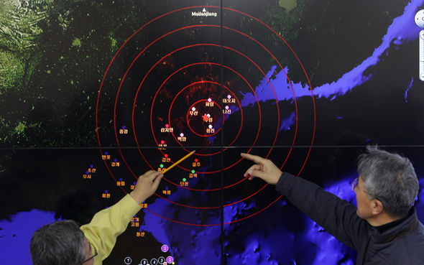GETTY
South Korean analysts following last month's nuclear test
Chillingly, before news broke today of the collapse, they had warned such a collapse could spread radioactive material far and wide.
They said: "The fallout can spread to an entire hemisphere."
Paul Richards, a seismologist at Columbia University's Lamont-Doherty Earth Observatory, said: “What we are seeing from North Korea looks like some kind of stress in the ground.
"In that part of the world, there were stresses in the ground, but the explosions have shaken them up."
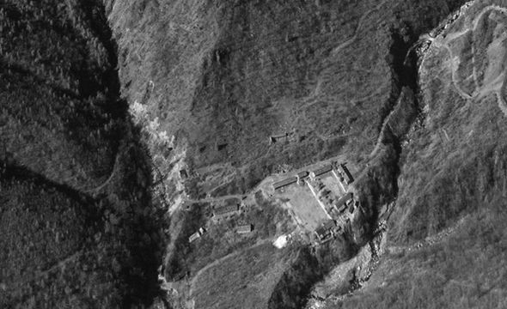GETTY
An area of the Punggye-ri nuclear testing site as seen by satellite
On Monday South Korea also warned another nuclear test at the site could lead to a total collapse of the mountain facility, causing a deadly leak of radioactive materials.
Even if a radioactive leak does not occurr, the disaster is a huge blow to Kim. The new tunnel was likely necessary to help modernise the facility and its collapse will severely slow North Korea’s nuclear progress.
Monitoring group 38 North said this month: “If North Korea were to attempt to continue testing under this mountain, such as in the area more to the eastern side, then we would expect to see new tunnelling in the future near the North Portal, still under Mount Mantap.”
The humiliating disaster could provoke Kim into holding a huge missile test in an attempt to save face.
Nuclear expert Joshua Pollack said Kim could make good on his promise earlier this summer to launch “the most powerful detonation of an H-bomb in the Pacific”.
He said: “North Korean leadership undoubtedly feels pushed into a corner.”
Experts are concerned a Chernobyl-style disaster could occur in North Korea
Experts are concerned a radioactive leak from the site could be as bad - or worse - than the Chernobyl disaster of 1986.
A nuclear accident at a plant in the Ukrainian town of Pripyat, then in the Soviet Union, killed 31 people and resulted in the mass evacuation and abandonment of a huge area.
Even today a 19-mile exclusion zone remains in place, with officials estimating the area will not be safe for human inhabitation for millennia.
The nuclear accident even affected the ecosystem and food chain, with domestically-sourced wild boar meat causing concern due to the now-radioactive mushrooms the animals eat.
===========================================================
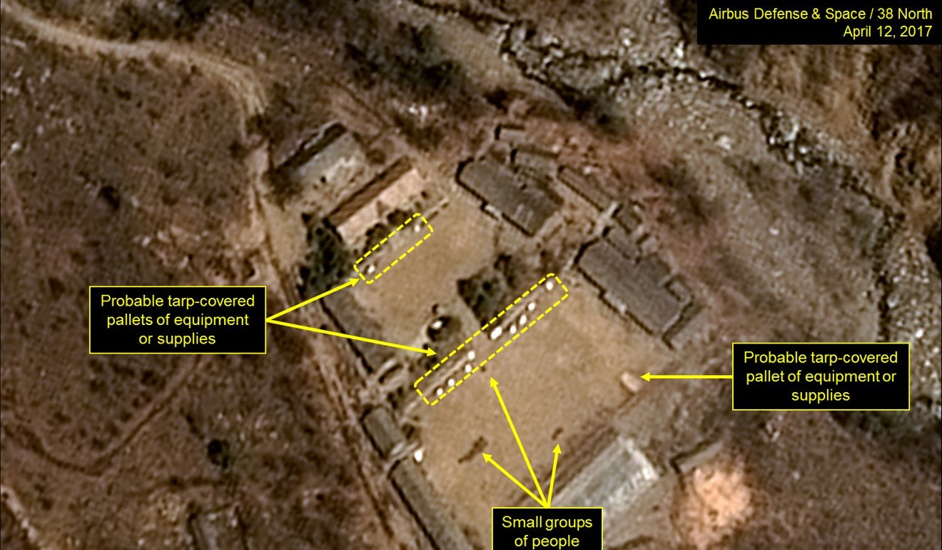
A satellite image taken a year ago of North Korea's Punggye-ri nuclear test site, showing activity that suggested Pyongyang was preparing to launch a nuclear test. Photo: AFP
The “rock collapse … was for the first time documented in North Korea’s test site,” Liu’s team wrote in a paper published last month in Geophysical Research Letters.
The breakdown not only took off part of the mountain’s summit but also created a “chimney” that could allow fallout to rise from the blast centre into the air, they said.

North Korea nuclear test site has signs of ‘Tired Mountain Syndrome’ after five blasts

Zhao Lianfeng, a researcher with the Institute of Earth Science at the Chinese Academy of Sciences in Beijing, said the two studies supported a consensus among scientists that “the site was wrecked” beyond repair.
“Their findings are in agreement to our observations,” he said.
“Different teams using different data have come up with similar conclusions,” Zhao said. “The only difference was in some technical details. This is the best guess that can be made by the world outside.”
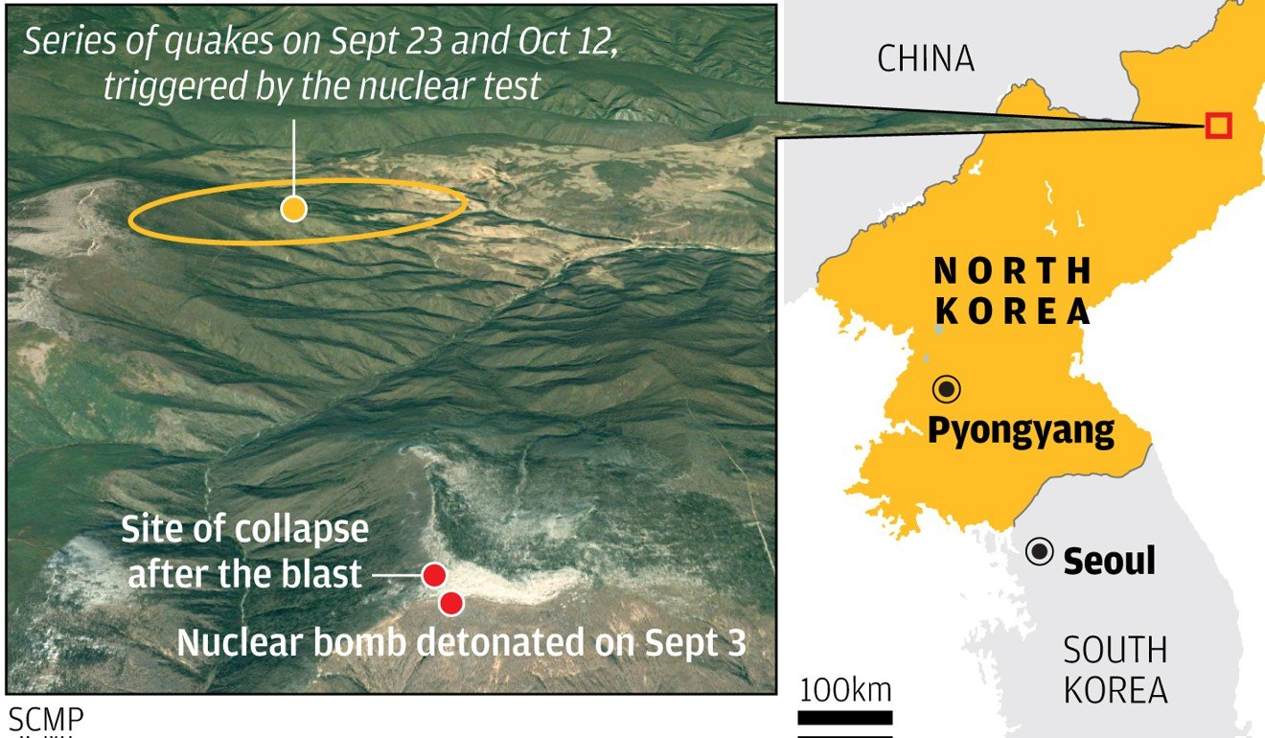
Speculation grew that North Korea’s site was in trouble when Lee Doh-sik, the top North Korean geologist, visited Zhao’s institute about two weeks after the test and met privately with senior Chinese government geologists.
US reveals how its forces would secure North Korea’s nuclear sites

Although the purpose of Lee’s visit was not disclosed, two days later Pyongyang announced it would no longer conduct land-based nuclear tests.
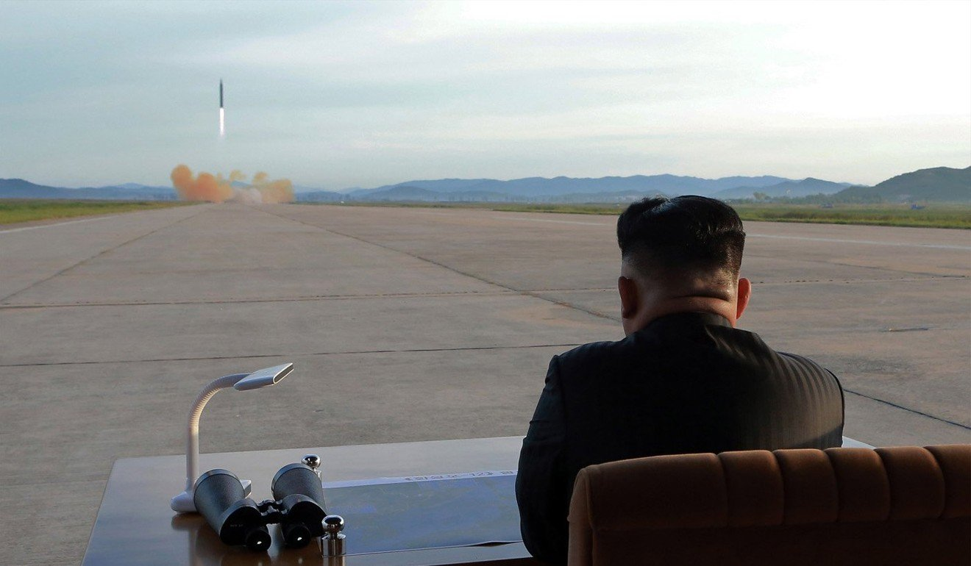
Kim Jong-un announced the suspension of nuclear testing last week. Photo: EPA
Hu Xingdou, a Beijing-based scholar who follows North Korea’s nuclear programme, said it was highly likely that Pyongyang had received a stark warning from Beijing.

Are North Korean quakes signs of instability at nuclear test site?

“The test was not only destabilising the site but increasing the risk of eruption of the Changbai Mountain,” a large, active volcano at China-Korean border, said Hu, who asked that his university affiliation not be disclosed for this article because of the topic’s sensitivity.
The mountain’s collapse has likely dealt a huge blow to North Korea’s nuclear programme, Hu said.
Hit by crippling international economic sanctions over its nuclear ambitions, the country might lack sufficient resources to soon resume testing at a new site, he said.

North Korea told its people Kim Jong-un visited China, but didn't mention denuclearisation

“But there are other sites suitable for testing,” Hu said. “They must be closely monitored.”
Guo Qiuju, a Peking University professor who has belonged to a panel that has advised the Chinese government on emergency responses to radioactive hazards, said that if fallout escaped through cracks, it could be carried by wind over the Chinese border.
“So far we have not detected an abnormal increase of radioactivity levels,” Guo said. “But we will continue to monitor the surrounding region with a large [amount] of highly sensitive equipment and analyse the data in state-of-the-art laboratories.”
Zhao Guodong, a government nuclear waste confinement specialist at the University of South China, said that the North Korean government should allow scientists from China and other countries to enter the test site and evaluate the damage.

Was North Korea to blame for radiation spike in north China city?

“We can put a thick layer of soil on top of the collapsed site, fill the cracks with special cement, or remove the pollutants with chemical solution,” he said.
“There are many methods to deal with the problem. All they need [to do] is ask.”
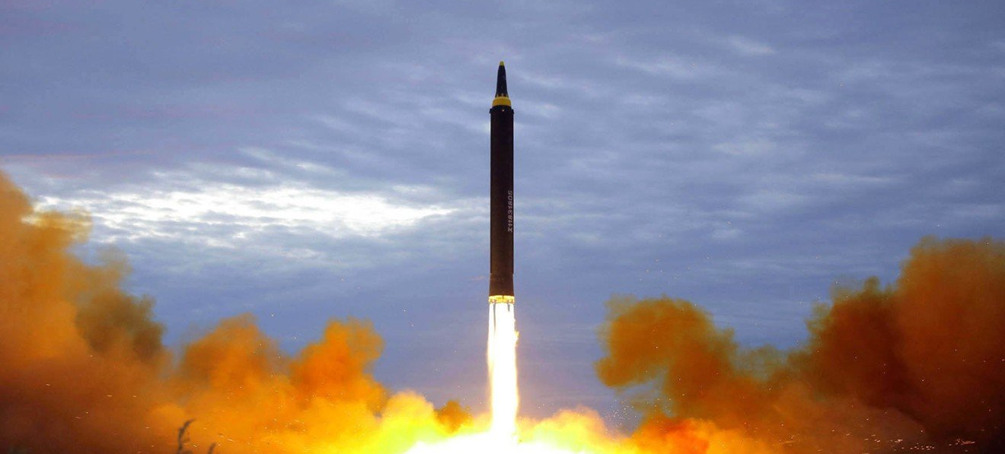
The nuclear test site’s collapse may be why Kim Jong-un has declared he would freeze the hermit state’s nuclear and missile tests and shut down the site. Photo: KCNA via AP

This article appeared in the South China Morning Post print edition as: nuclear test site has collapsed, studies confirm

